
September 2005

Zonta Club of
West Moreton Inc.
Inside this Issue
1 | President’s Message
2 | Zonta Events, Meeting Details, Members News
3 | Committee Reports and New Member Profile
4 | Events
5 | Events
6 | Other Diary Dates
7 | Minutes
Our Club Website :

http://westmoreton.
zontadistrict24.org/

Zonta Club of West Moreton Inc.
PO Box 505
Ipswich Q 4305
Club No. 0900; District 24; Area 6

President’s News
.
.
.
Zonta Newsletter
Dear Zonta members,

I have no doubt we are all looking forward to the many Zonta functions coming up in October.
We are anticipating several guests to the Birthday dinner who are very interested in becoming members of Zonta West Moreton. Two of these guests are a result of the picture of the Leadership for Girls Graduation in Ipswich’s Own, so it is great to see a tangible effect of the community’s increasing awareness of Zonta.
Sadly, due to commitment overloads, ‘Jazz on Track’ will not be on our calendar this year, however, I am sure it will be back bigger and better than ever next year.
Our new aprons have arrived, and do look good. They will be on sale at our Birthday dinner at Fenton’s at $20.00 each for West Moreton club members. We will sell them for $25.00 ordinarily, to assist in a small way with fund raising.
The cookbook is beginning to come together – what we need now is for all members to put together 3 – 4 of your favourite recipes, if possible, as a Word document, which really helps the publishers.
Recipes can be anything from your grandmothers special afternoon tea cake, through to recipes that are low-fat, low GI, or quick to prepare after work. As we do not wish to contravene copyright laws, please remember recipes need to contain your own variation, if the recipe comes from another cook book.
The time line to production is still to be decided, but the first promotion evening to attract sponsors will be at the Croquet Club, in Queen’s Park.
Could you please (in your spare time) have your recipes to me by our October meeting?
Email is the preferred mode, but I have an eager family member on hand to enter any that are hand written.
If you have any tips, suggestions, quotes, or little anecdotes please include them also.
That evening will be the opportunity for us to showcase some of our own great baking skills, which are always so evident at the Heritage Homes tour luncheon, and impress potential sponsors with contents of the book.
Looking forward to seeing you all at Fenton’s. Don’t forget to get your acceptances/ apologies to Vicki.

Leonie

SEPTEMBER MEETING DETAILS

MONDAY 26th September
6.15pm for 6.30pm
at FENTON’s RESTAURANT

Speaker :
Ms Carol Haffke
CareFlight

Dinner Cost - $30 per person

IMPORTANT :

Please phone Vicki Doig on 3812 8009

please also indicate if you are bringing a guest
or with apologies
or any special dietary requests
(e.g. a vegetarian meal)
before 7.15am Friday 23rd September.

REMINDER: If apologies are not received by stipulated time of the meeting week, you are required to pay for the cost of the dinner. The Treasurer will send you an invoice.
For September …
Door Duties : Vicki and Heather
Speaker Introduction : Robyn Hargreaves
Speaker Thanks : Kath Everett
Grace & Toast : Myrtle Green

.
.
.
.
Zonta Events

Date : Sunday 25th September 2005
Toowoomba Garden City Club’s Jazzfest in the Garden

Date : Monday 26th September
6.30pm at Fentons
Zonta Birthday Dinner Meeting

Date : Friday 14th October
Newsletter items Due – to Sue Hutley. Phone through your news on 3202 3436

Date : Saturday 1st October Cambrian Evening

Date : Sunday 2nd October - Spring Walk – see details in this newsletter

Date : Friday 7th – Sunday 9th October
Gold Coast
District 24 Conference
Zonta – Making a Difference
June 24-29, 2006
Zonta’s 58th International Convention - Melbourne

Members News
Congratulations and Many Happy Returns to Margaret Evans on a very special birthday recently !
Also to Heather and Bert on their 55th Wedding Anniversary.
Do all members know why the initials gA are important? They mark the brand for Gaye Anderson’s own professional hair care range, launched this month!! Congrats Gaye.
Welcome Back to Queensland Pam S – we look forward to hearing about your trip.
Congrats to Marie K who became a grandmother again, when Kristy gave birth on Monday 12/9 to 3rd grandchild – a grandson Trent Steven.

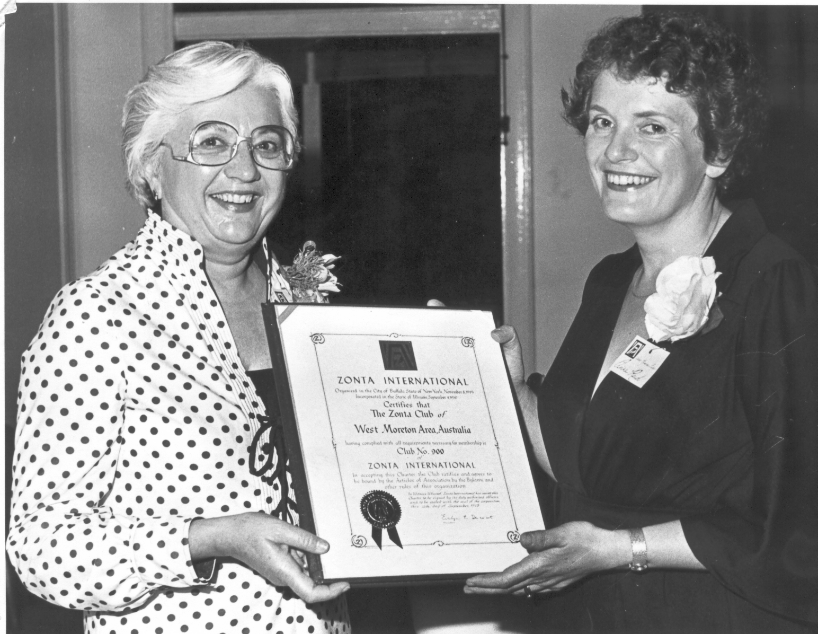
Zonta Club of West Moreton Area Inc. Charter Presentation – in photo L to R Cornelia Hodges First Vice President of Zonta International to Dr Anne Reid Charter President of Zonta Club on 24th November 1979

Committee Reports

UN Committee Report:

Just a reminder that Stephanie Daly -- Regional Director, Department of Foreign Affairs and Trade will be the Guest Speaker for the United Nations night in October.

Margaret, Robyn, Sheila, Cheryl and Maria

Committee Report : Program
Update report from the Programs Committee:

We are really looking forward to our (26th) Birthday Dinner at Fentons' Restaurant on September 26th, and hope it will be memorable with a different venue and menu. Our speaker will be Carol Haffke, from CareFlight, and we hope to continue to present her, and subsequent speakers, with wine from (the local) Warrego Winery, and a certificate of appreciation from the Club.
We would ask members again to be seated for 6.45pm.
For dinner duties, please we seek the assistance of :
Robyn Hargreaves for the introduction
Kath Everett for the vote of thanks and
Myrtle Green for the Grace and Toast.
For the November meeting (normally a business meeting) we hope to have Hugh Lunn, author and broadcaster, as speaker.

Pam van de Hoef ,Chair

Membership Committee Report :
Ladies, please may I have your old Zonta magazines for dispersal to new & prospective members! Please bring them along to the meeting.
We have a new prospective member who will be inducted at the November meeting & we will be formally introducing a transferring member, Julie Mayer from Maryborough.
The apologies system is working well. Keep it up ladies & a BIG THANKYOU from the committee.
We are going to have a NEW members night in February next year. More at the October meeting!
Vikki & I did some networking at the Ipswich Chamber of Commerce Breakfast last month. Some teachers from the business department showed great interest in the Boilerhouse Project….so get out there & tell people about Zonta!!!!!
Gillian
and Heather, Myrtle & Vikki
Status of Women Committee :
The Breast Cushion Making will be held on Sunday November 6th at Building 8, University of Queensland, Ipswich Campus. More details at the next meetings.
Marie K

Reminder :
AN INVOICE WILL BE AUTOMATICALLY SENT TO MEMBERS FOR THE COST OF THE DINNER IF THEIR NAME IS NOT ON THE APOLOGY LIST. APOLOGIES NOW DUE BY 7:15AM ON THE FRIDAY MORNING BEFORE THE MEETING.

New Member Profile :- Tina Kelly
Although born in Ipswich, I grew up in an idyllic location, Numinbah Valley (Gold Coast Hinterland). I love animals, especially horses, and from the age of 7 I had a small pony named Jock. Jock and I went everywhere together – to/from school, visiting friends and basically anywhere within a couple kilometre radius of our family home. At 11, my family moved back to Ipswich, primarily to allow my older sister Maria (and eventually myself and my brother Todd) to have ease of accessibility to secondary and tertiary educational facilities. This was a huge culture shock as the three of us went from a country school of 21 children to a school population of several hundred – St Mary’s.
In my final year at high school a member of the Amberley RAAF base came and spoke about the role he performed as an engineer within that organisation. This information as well as my passion for physics opened up a career option which I had never considered before. I applied to join the Air Force and in the final round of selection was rejected based on their testing regime which deemed that engineering was not the career path they expected me to follow. This only inspired me more and I went on to study at the University of Queensland (St Lucia).
On finishing my degree I gained a position in Brisbane working for Queensland Rail (QR) at a time when the Electrical Overhead wiring was being established. This resulted in the railways removing a major portion of the open wire pole route and installing state of the art optical fibre and microwave radio transmission systems for train control operation (In the year I joined QR, it had more fibre in the ground then Telstra!). I was part of a team that installed equipment and commissioned operational services from Nambour to Gladstone and Mackay to Bowen, and then went on to personally roll out transmission systems from Hughenden to Cloncurry and Charters Towers to Hughenden.
I have been fortunate to have had excellent managerial support in the career development opportunities I have sought, which has resulted in experience within telecommunications disciplines such as train control services, transmission systems, data communications and maintenance. I also spent several years in a project management role responsible for complete engineering packages such as balloon loops for coal loading facilities.
Today I am not as technically hands on as I once was, as I manage a group of engineers and technical officers, and am responsible for the delivery of QR’s telecommunications projects. This can range from providing a new telephone exchange at Townsville for QR services in the region, to installing telecommunications bandwidth from Toowoomba to Roma to improve train control services in the Far South East, to installing train control radio and telephone communications for the operation of a new Coal Balloon Loop in Central Queensland, and to providing CCTV and other forms of security surveillance across QR’s passenger facilities (e.g. stations, carparks).
I’ve only recently moved back to Ipswich after spending 5 years living at Sherwood. I fell in love with my house when I saw it as part of last year’s Zonta Heritage Tour – yes that ticket turned out to be quite expensive!!!!. I believe Ipswich has lots of potential and I’m looking forward to (and being a part of) seeing the city develop and change (although I hope we always maintain a sense of where we’ve come from – Ipswich’s heritage).

Leadership for Girls Update
For the final term of the year will again have a Leadership for Girls group, and a new course leader – Julie Mayer.
Julie has been working as the Behavioural Studies Placement Officer at UQ Ipswich, and she is a past Zontian. You will meet Julie at our Birthday Dinner as she is transferring to our club from Maryborough.
Leonie and Sue H continue to liaise with Michael Cuthill from the Boilerhouse Community Engagement Centre -- and now Julie regarding the course.
----------------------------------
September Theatre Night at Incinerator
Tickets are still available for the Williamson play night on Wednesday 28th September. Please bring your friends along to “Money and Friends”. $20. Kath will have tickets at the September meeting, or phone to confirm on . Please also discuss food with Kath for the night.

UN Spring Walk
Robyn Hargreaves is now co-ordinating the Spring Walk on Sunday 2nd October. Please meet at the Quarry Street entrance to the Denmark Hill Environmental Park at 9am. Following the walk, morning tea will either be at the park, or at Robyn’s home.
Final RSVP’s at the September meeting to Robyn.

Zonta Badges

Eirys has checked and the pins and other badges are on their way.

Meeting the Challenge

Good Luck to Margaret, Joc and Eirys who are finishing the Riverbend Readers’ Challenge. We look forward to hearing what their favourite books were.

For Your Diaries –
Meetings Dates 2005:

24th October- United Nations
28th November - Business meeting
12th December - Christmas Dinner

Get Cooking – Zonta Aprons Now Available

The West Moreton Club’s Aprons are now ready for members to purchase. $20 is the members price. Please bring along your cash or cheque to the September Birthday Dinner meeting to buy your supply for Christmas presents.
The aprons will also be sold at the District Conference and at future functions for $25 (the non-club members price).


October Zonta Fellowship Event

Theatre Restaurant
The Cambrian Choir’s Theatre Restaurant, ‘Some Enchanted Evening” will be on Saturday Evening, 1st October. Thanks to those that have confirmed their ticket and looking forward to an enjoyable night !

2005 Ipswich Breast Cancer Breakfast
This year the annual breakfast is at Brothers Club on Friday 21st October @ 6.45 for 7am & will finish by 8.15am. Cost is $16. All proceeds are going to Breast Cancer Research. The speaker is Dr. Margaret Lewis, who will have just returned from attending an International Conference in London on Breast Cancer Research. Margaret is a dynamic speaker & it will be telling us the latest information. It will be a good networking breakfast for Zonta who is one of the major ticket sellers!!!! You cannot afford not to go as 1 in 12 women will have a brush with breast cancer. Books of 5 tickets are available from Gillian at the dinner meeting.
******
Myrtle Green reports that a close relative was recently full of grateful praise for the Zonta Breast Cushions which she has received after recent surgery at Toowoomba’s St. Vincents Hospital.
Don’t forget we are making our club Breast Cushions on Sunday 6th November.

You’re invited ….
The Zonta Brisbane West Club is hosting an interesting speaker at their October meeting and have invited all interested West Moreton club members to come along.
Date : 17th October
The guest speaker is Dr. Ken Henry from Project Africa. Dr Henry is involved in taking medical supplies to Uganda and providing nurse education training in that country for local nurses. He specialises in AIDS care. The meeting will be at Milpera School, Chelmer and will be catered for by the Eritrean community. $20 for Eritrean meal and glass of wine.
Contact : Sandra Venn-Brown
07 3405 6973
041 7744 152
sandra.vennbrown@dir.qld.gov.au

Other Diary Dates :

8th October – IGGS Ball. Sue Hutley has tickets (which are going fast and in limited number) $90. See Sue if you would like to join her table.

14th – 16th October
Ipswich Library Expo – more details at www.library.qld.gov.au
- with interesting classes and information sessions.

26th October, 7am -11.30am HERizons symposium: imagining the future of women is a symposium, in celebration of 100 years of women's suffrage in Queensland and 40 years of the Indigenous right to vote. It is being held, at the Brisbane Convention & Exhibition Centre, South Bank. Join host author, columnist and broadcaster Madonna King at a lively morning discussion and book launch which imagines the future for women. A panel of prominent women speakers will explore their impressions and ideas of what is on the horizon for the next generation of women.
For more information contact Bre O'Neill, Public Programs on 3840 7768 or email Breanne.O'Neill@slq.qld.gov.au

2nd November
Cocktail Party at GAL to celebrate 100 Years of Women’s Suffrage with the other women’s service clubs. More details next newsletter.

10th November
Suffrage Morning Tea at GAL.
More details at the October Meeting

