ZONTA CLUB OF MOUNT ISA Inc Newsletter

P O BOX 2442, MOUNT ISA QLD 4825

President: Michele Savoye PH 4743 5832 N/Letter Editor: Liz Ryan
Vice President: Carolyn Hay PH 4743 3163 Any submissions to N/Letter email to Liz Ryan - MIPP@bigpond.net.au
SEPTEMBER 2005

PRESIDENT’S REPORT FOR SEPTEMBER 2005.

Bonjour Zontians!

Zonta Breakfast Club put on an excellent “Poets Breakfast”. It was very well organised and had wonderful Poets making a guest appearance. Although the hour was very early, Melanie, Sandy and Veronica soon had me wide awake with their poetry which was full of life and wit. I was impressed with the number of our members who attended. It was great to see so many of us getting behind our “sister breakfast club” and helping to make the morning a real success.

At Rodeo time we were once again at the corporate tent working very hard. Linda’s organizational skills ensured that the week-end ran very smoothly. The major sponsors dished out plenty of praise for our efforts so take bow girls and many thanks for all who assisted. Many cartons of beverages were delivered by Mel (Mr Muscle) who is now an honorary Zontian and boy does he deserve it!

Congratulations to Sarah and Doug on the safe arrival of their beautiful baby boy, Thomas, who couldn’t wait to make his grand entrance and arrived a month early.

Congratulations also to Jennifer Graham the 2004 district winner of the Young Women in Public Affairs award who has now also been awarded the INTERNATIONAL award as well. This is the first time that regional Queensland has won this prestigious award. Well done Zonta Club of Mackay!!!

We, together with the Breakfast club, have decided to sponsor the People’s Choice section in the October Mount Isa Art Exhibition. $100 per club is a very cheap public relations exercise in our quest to promote the good works of Zonta to as many people as we can reach.

Finally, I hope everyone is in party mode for our international birthday dinner meeting on the 21st-12 years old. Hip Hip Hooray!!!!! Word from our hard working Membership Committee is that we can expect to welcome a new member, Kerry O’Connor into our club at our next dinner – What a lovely Birthday Present for us. So Ladies, see you there….

Zonta On!!!!

Michelle

Multicultural Dinner Night Wednesday

21/09/2005 7pm start

Dinner meeting is a multicultural affair.
Don’t forget to dress up in your committees
Country!

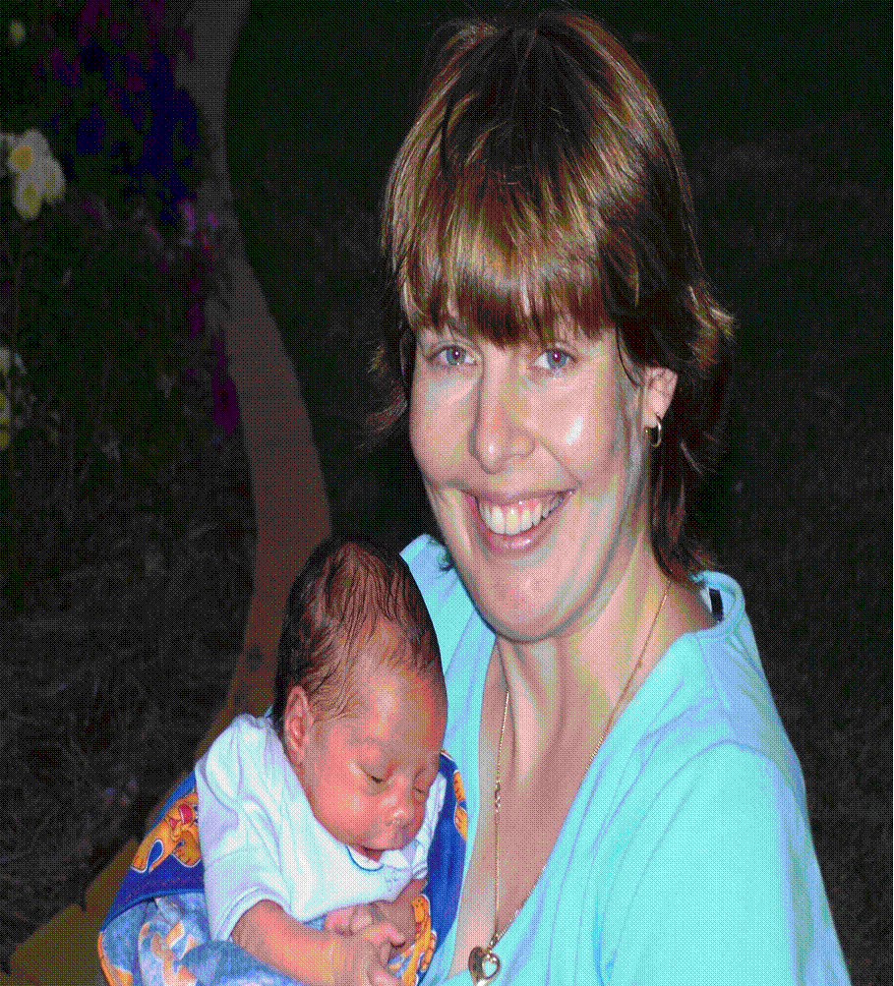
Our Sarah and Lil’ Tom
WELCOME TO THE WORLD TOM!

Last month there was a bit of a surprise in Sarah Fraser’s life. She had been busy with organising the 50th Anniversary Celebrations of Townview State School. She had a few more days of work to go, and was looking forward to three lovely weeks of maternity leave to get herself ready for the birth of her baby. (If the truth was told – there was a fair bit to get organised still, little things like setting up the nursery, getting the bassinet, car seat, nappy bag…..)

Then Sarah had a scan at the hospital at six o’clock. Driving to the hospital, her waters broke! (Lucky no one else was on the road from Pamela Street to the Hospital as she would not have won any prizes for safe driving!) Dr Warren took one look at her and sent her straight to get a caesarean. So by 7.45pm she was a proud – and somewhat shocked – new mum!

Thomas Douglas Ranie was born on Tuesday, 23rd of August – exactly four weeks early. He was (and still is) a little fella. He weighed 5lb 6oz when he was born and much to his mum distress, he was whisked away and put into a humidicrib with plenty of tubes and monitors. However, after two very long weeks Sarah and Tom came home (appropriately on Father’s Day!).

So now Tom is getting used to the world and Sarah is getting used to having Tom in the world!! He is the most beautiful baby in the world (well, so Sarah thinks anyway). He is an angel during the day, however, Tom thinks it is play time at two in the morning – his mummy is still getting used to the lack of sleep at present! But with one little smile (of course it is not wind) everything is all worth it!

The Newest Mum - Sarah!

FINANCE AND FUNDRAISING NAZI REMINDERS ALIAS THE VERY PREGGERS SHANNON!
Reminder No.1
A friendly reminder Fellow Zontians about the two bottles of wine or spirits for our end of year raffle. Only three good little Zontians have given over their bottles.
I have a list and I am watching!!!!!

Next month in the newsletters we are going to be featuring articles on what your committee’s role is in Zonta and what you can do to help.

OUR BIRTHDAY GIRLS
FOR THIS MONTH ARE!
14th September Penny Marshall
21st September Nellie Scarsi
11th September Maureen Sweeney

Next Meeting
Wednesday 21ST September
Our Birthday Night
7 for 7.30pm
At Terrace Gardens

If you can’t attend, please apologise to
Margot Dunstan
On
PH 4743 5718

