ZONTA CLUB OF MOUNT ISA Inc Newsletter

P O BOX 2442, MOUNT ISA QLD 4825

President: Linda Harrison Wk 4743 6733 N/Letter Editor: Kate Larrazabal
Vice President: Michele Savoye Any submissions to N/Letter email to
kalouclarke@bigpond.com
OCTOBER 2004

President’s Patter

Hello Ladies,

I am getting old!!!!! Last month I forgot to thank two people who put their all into the Wheelies Day. Liz Ryan and our littlest HonZon, Suzie Ryan were there and did a great job. Sorry Liz and Suzie. I can only blame it on old age and too much happening in our lives at the moment! (Hope you’ll forgive moi)

CLONCURRY TOUR
What a great weekend! We drank, nibbled and gossiped our way though a truly lovely time. I got to know Sarah and Sam a whole lot better. (I think I might have a couple of life long friends there!)

We managed to have the odd party game, with some very naughty bits (donated by Deanne – I understand she has too many! Only kidding!). Sue Shield was the wag of the weekend, she even wore her horse nickers to breaky on Sunday. If you weren’t there, we should have some photos at the next meeting.

Our resident digital Photographer, Margaret Medley took a whole heap. I might add, some of them are a lil’ out of focus. Yes she was tippling along with us. But 90% of them are great, and I’ve included a few for you to see us at our best?

Shannon was the first Nazy Tour Guide. You know, “You will be here at 5.30pm”. “Drink up as we have to go to the bar for more drinks!” All kidding aside, without her expert organisational skills, the weekend would not have been the success it was. Big thank you to Shannon. If you’ve got a few minutes, ring her and tell her how much you enjoyed it.

I’m electing her our Tour Organiser/Guide for the next year’s District Conference in Brisbane. Start saving your pennies girls, as it’s gonna be a blast.

Kimoozu (Liz Ryan – that’s her African name) did not manage to do any Reiki Sessions on the weekend. More’s the pity, as I had her booked and everything.

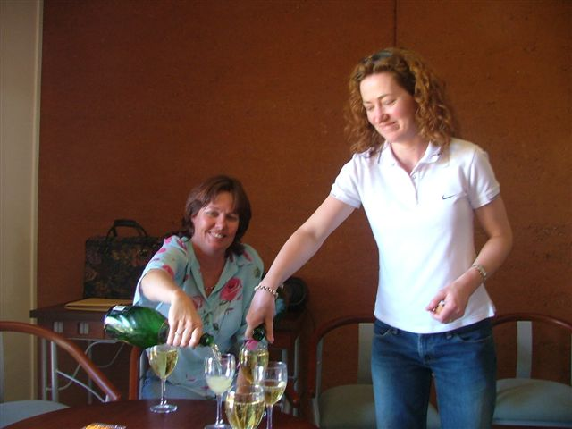

LIZ AND MARIA – POURING THE PLONK!

A few statistics for non-attenders –

Number of bottles of wine drunk 19
Number of chairs dragged into
Party Central 16
Number of dirty jokes told! 5

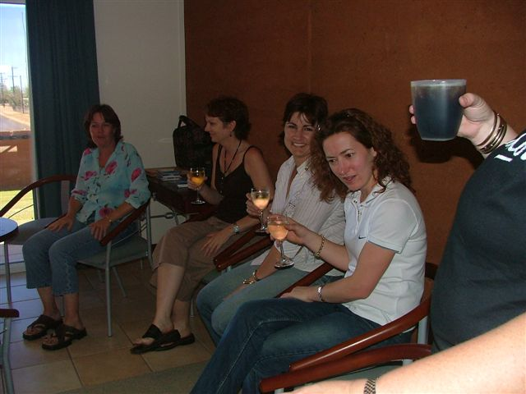
Cheers! Party Central nearly in Full Swing!!

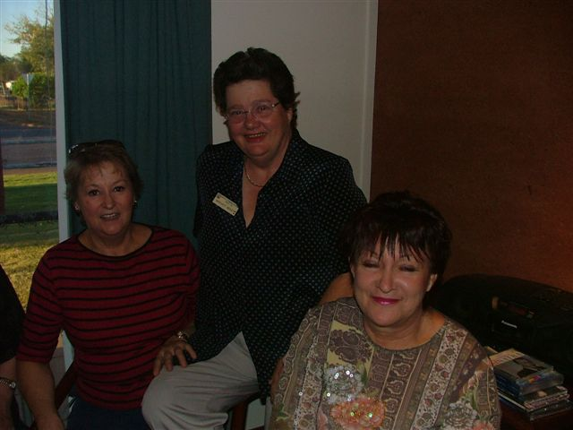
Margaret finally gets in a photo – Note Sue asleep!

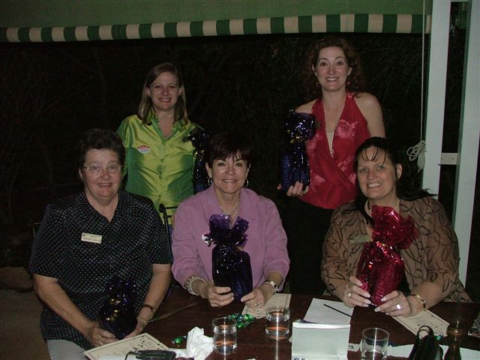
Guess which Zontian has no nickers on? The winners of our Party Game!
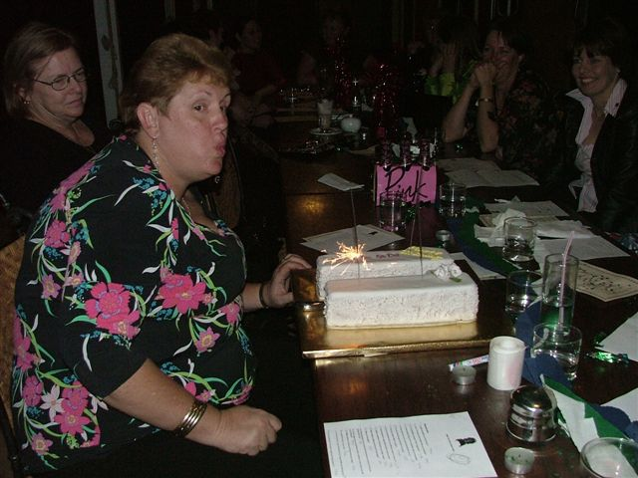
Those bloody sparklers won’t blow out! El Presidente with Birthday cake.

Read Cherry’s report in newsletter for more on Cloncurry weekend!

TOWNSVILLE METRO CHARTER DINNER
What a great weekend a few intrepid travellers had in Townsville. I flew over on Thursday. Had to do a little business and lot of shopping.
Cherry, Shannon, Maria and Shannon’s kids turned up 4.30pm Friday Arvo. Paula and Sue from the Breaky Club turned up on Friday Arvo too.

Repaired the lippy and then off for Margaritas at Cactus Jack. Cherry and I managed to get 4 down through the happy hour. We couldn’t get a table at Cactus Jack (even with the evil eyed looks we gave a couple of tables), so we wandered off to a little eatery Cherry new about.

I took the two baby Zontians out for a night of dancing. Shannon and Maria, here I was thinking I’d lead them astray. Phew, how does one keep up with ‘em. Maria has a fetish for tambourines, and wound up as part of the band at an Irish Bar we went to. After much cajoling, we managed to get her to relinquish her tambourine and hobble (high heels are killers) home.

Saturday saw us divide up and shop till we dropped. We were certainly good for the economy of Townsville! I grabbed Dianne H. from the plane and went out and had lunch and ice cream.

Saturday was very nice. Out of 70-80 people at Charter Night, there were 11 Mount Isans and Ex-Mount Isans. Wot a team.
Vicki is doing very well, and she has some wonderful women in the Club with her. They’ve promised a great showing for Area 7 Workshop in May 2005.

On Sunday, Cherry, Shannon, Maria and kids managed to get some more shopping in at the markets before they wended their way home.

Paula and Sue boosted the Townsville economy at the markets as well.

We’re all home now, and very tuckered. Still, wot a lovely weekend we had. (The fellowship was the best!)

OCTOBER MEETING

We are having a working bee at our October Meeting. We will be making Care Packs for the women’s shelters in town. Meeting as usual, then on to making the Care Packs.

Am having trouble finding cheap combs. HELP! Need 30, can someone tell me where I can get cheap combs?????

VISIT FROM AREA DIRECTOR

Also at our October Meeting, we will be having a visit from our Area Director, Libby Gleeson.

Libby is having a flying trip. She turns up at 6.30pm and leaves on Thursday morning.

Please come along and meet our Area Director. The more people there, will make her go WOW! What a great club this Mount Isa Club is.

WINE RAFFLE

WHO HAS FORGOTTEN TO BRING IN THEIR WINE TO THE SHOP!! NAUGHTY ZONTIANS! I DON’T HAVE ENOUGH TO DO A BASKET UP YET. SO BRING IN YOUR WINE.

Tickets were delivered out early in the month. I have flyers available if you need em. So sell, sell, sell.

BIRTHING KITS
We are going to have a working bee to make Birthing Kits. Please keep the following date free.

Sunday, 5th December 10am till we finish
At Terrace Gardens - Lunch provided.
If you can’t work all day, please come along for a couple of hours.

CAROLS BY CANDLELIGHT
We have a chance to get some funding from AMP (Dollar for Dollar). To do this we must do some fundraising of our own.
We will be selling Fairy Floss at Carols by Candlelight in December (not sure of date yet, will advise soon). We will make it on the night, as it is a better draw. More information at October Meeting from Cherry.

Well, finally, that’s all from moi. See you at the next meeting. Please come along, it will be a fun night, wot with working on Care Packs and Libby’s visit.

ZONTA ON!!
Linda Harrison
El Presidente.

Any submissions for Newsletter, must be in
3rd November
(first Wednesday of every month)
email: kalouclarke@bigpond.com

APOLOGIES!
Must be phoned through to

Margot on
4743 5718 Wk

Or 4743 3602 Hm
No later than midday on the Monday before the meeting. Failure to apologise will result in the member paying $22 for meal at the next dinner meeting, or they will receive an invoice for this meal.

OUR BIRTHDAY GIRLS THIS MONTH ARE
Sarah Fraser 9th October
Marilyn Jacob 21st October

*******************************

Thought for the Month
You are here for a purpose.
There is no duplicate of you in the whole wide world.
There never has been.
There never will be.
You were brought here now to fill a certain need.
Take time to think that over.
LOU AUSTIN

THE 11TH BIRTHDAY BASH
By Cherry Brosnan

20 intrepid travellers headed off at various stages of the day on Saturday 18th, with the intention of rendezvousing at the Leichardt Hotel for a spot of lunch as a precursor to a night of revelry.

We knew were in the right spot when we spied a group of young boys gathered around the “Beast” – Yes, Paula and Sue had arrived first in the bash car and with lights flashing and sirens blazing had broadcast our arrival in Town. We had a very nice lunch and the true sharing spirit of Zonta shone through when Maria, five seconds after ordering her lunch, spied Margaret’s pasta and immediately forgot the 11th Commandment “Thy shalt not covert thy fellow Zontions lunch.” Margaret, being a girl guide to her shoe soles, handed over her pasta and kindly consented to have whatever Maria had ordered. As we left the hotel we noticed The Delations would be performing in the Main Bar at 9pm and we filed that information for later use.

A drink or two later, we found ourselves at the front desk of the Gidgee Inn with the Tour Nazi, Shannon handing out keys and orders simultaneously. We were to settle in to our rooms and then head to Linda’s Room (an executive suite, no less) as it was designated Party Central.

Party Central also became Collection Central for all the Soap, Shampoo etc that the Marauding Zontians looted from their rooms. (Point to note for the un-initiated – take your own soap – you may not use the soap in the rooms – Serenity House needs it more.) The bed, being superfluous to our needs was bundled into a corner and we proceeded to move chairs and tables from our rooms into Linda’s.

Shannon and Linda then gave a performance that would have won them gold in the Snatch and Lift section at Athens and managed to carry a king size esky full of ice and champers from the car to the room. We all felt so sorry for them that we made sure it was much lighter load for them to transport back to the car the next day.

The fun and games began! By 3.30, the Head Hun, Shannon, ordered everyone back to their respective rooms to rest for the evening festivities, before once again meeting up at Party Central at 5.30 dressed in our evening finery. I think she was really hoping for a bit of decorum when we met with the Cloncurry ladies for drinks at 7.

Unfortunately, my room was next door and I am here to tell you that not everyone obeyed instructions to rest. At 5.15 Linda chased those who considerably lightened the load in the esky and will remain nameless, back to their rooms as they had 15mins to get dressed and be back to start again. By this time the late comers had arrived and Vera, Sue and Margot, not to be outdone by those who had managed a five hour start, immediately got into the party mode.

Shannon and Maria had planned a few ‘ice breakers’ to get the ball rolling and it wasn’t long before we found out that Paula has always had a penchant for the name ‘Peaches,’ Dee wishes she would be called Deanne, Shannon was named after a girl found floating in the Thames River (but I already knew that because I am her Mother). Sarah always wanted a name that could have been shortened into a nickname and Maria was named after the lead in West Side Story. (That explains her inclination for impromptu performances of Shania Twain).

Pass the Parcel proved a hoot. What sort of explanation would Margo give Bruce when he found the fur covered handcuffs in her port on Sunday? So delighted was Sue with her “Horses Head Jock Strap that Whinnied when Stroked” that she wore it to breakfast the next day. (I don’t think she had any toys when she was a child!)

Dee oops! Deanne produced a beautifully decorated 11 Cake she had made for the occasion and we headed off to join the Cloncurry ladies in the Dining Room. Seven ladies, including one of our very own Charter Members, Gay Shepherd, who owns the Post Office Agency, turned up to meet us.

We had a most delightful meal and the company was great. In the small space around me I had an Archaeologist who works for Main Roads, a flying minister’s wife who serves with her husband, a choreographer now wearing the hat of a domestic violence worker, one lady who has been awarded an OAM, two glamorous accountants who definitely could NOT use their personalities as contraceptives (as the old joke goes), a very youthful engineer who loves Frank Sinatra, a Rodeo Queen and a Charity Queen to just mention a few.

Every lady at the table had something special to contribute to the conversation and to society in general. It is certainly true that Zonta allows a diverse mix of women who would otherwise never cross paths to meet and enjoy fellowship.

By this stage we were either laughing or crying in our champers as the word had leaked through that the Cowboys had dispensed with the Broncos and the Lions would have a shot at their fourth premiership. We decided we would give The Delations at the Leichhardt a miss and retired to Party Central. One drink later and we all retired to our rooms without as much as one order from the Party Nazi.

Breakfast on the terrace was at 8.30 and Sue and Paula were the last to arrive, both with a baby bottle of Champagne to toast the weekend. Sue was of course, wearing her new toy, but she did have the decorum to cover it with her bag as she walked through the dining room. Unfortunately, she nudged it with her bag and it neighed and whinnied all the way to the table much to the wonderment of the other dinners.

Yes, we hit the Shop. Maria even managed to buy a pair of shoes and Linda found a few accessories to aid her in her new crystal jewellery making venture.

We headed home and a few carloads detoured into the Chinaman Creek Dam for a peek. Paula followed us up hill and down dale before telling us that the breaks on the Bash Vehicle were not really functional. We immediately got to the lead and in that formation, we left the bright lights of Cloncurry behind us.

Fifteen members of our club, four members of the Breakfast Club and one friend, made up the contingent that celebrated our birthday. Maria and Shannon proved themselves to be Organizers Extraordinaire. Sincere thanks to all of the above for making our weekend so memorable.

OCTOBER DINNER MEETING
WEDNESDAY 20TH OCTOBER
7 for 7.30 at TERRACE GARDENS
WORKING BEE AFTER DINNER AND MEETING TO MAKE CARE PACKS FOR WOMEN’S SHELTERS.
OUR AREA DIRECTOR WILL BE VISITING AS WELL!!

“COFFEE CONVERSATIONS”

HIGHLIGHTS OF OUR MEMBERS PERSONAL LIVES

Sorry Ladies it’s all about me! But I will make it short.

In case you missed the local newspaper, my eldest son Jeff won two gold medals and the Australian Championship Trophy at the National Junior Lawn Bowls Competition recently. Since moving to Brisbane in January, that first week, Jeff found a terrific job as a Broker, bought a car and was selected to play in Men’s 1st division for his club and this year he has consistently won many major events around South East Queensland not to forget the prize money he has collected. I can’t wait to see him at Christmas and also to celebrate his 18th birthday. I feel very honoured to be blessed with such a wonderful, talented son and as I say to Shawn we are the proudest parents of an “Australian Champion”
Liz Ryan

OCTOBER BOARD MEETING

Mt Isa Zonta will host the Area 7 workshop in May 2005

Libby Gleeson, our Area Director will be at our October meeting. This is also United Nations Day. We will be celebrating with a delicious meal of international food. (Wednesday, October 20th, at Terrace Gardens, 7 for 7.15 start).

After our meeting and meal on Oct 20, please stay and help with a working bee to make care packs for women forced out of their homes because of domestic violence.

November dinner meeting is our Christmas meeting! Guests are welcome, and there will be an outback theme.

December meeting is a barbecue at Linda’s lovely new home on the hill.

5th December (Sunday) working bee to put together birthing kits to be sent to third world countries

