

The Metro

Zonta Brisbane Metro Breakfast Club Inc.

Issue 23
2 November 2005

Aerobics at Grevillia House
A

Grevillia House is the name of the residence for the girls in the Brisbane Youth Detention Centre. As discussed at the last Club meeting, a small group of Sarah, Sally and Rita (Cath had to work on the day and Amena had hurt her body at the gym … I always knew exercise was bad for you!!) fronted up at the Detention Centre on Saturday, 15th October with two DVDs (bought) and two videos (donated) to spend some time with the girls at Grevillea House.
Danny, the weekend recreational officer, took us to Grevillea House and then wholeheartedly joined in the activity and fun once we got there. Grevillea brought home to us that the girls really are in a prison … when we had seen them in the visitors centre on our last visit, we didn’t get the lock-down closed-in feeling that comes from where they actually live.

Having said that, there was a large open space where our shorts-and-teeshirt-clad group bravely attempted the exercises, joined by the staff at the Centre and the girls.

The Fit, Firm and Flexible videos (exercises and yoga) were probably the best received, though they were the last two shown and perhaps all of us were getting a bit weary by the time we got to them. We all laughed a lot, at ourselves mostly!

Feedback from the Centre has been very positive, both from the girls and from the staff. It does feel good to provide hands-on support to a group of very underprivileged young ladies.

The SOW Committee has decided to make a long-term commitment to this project. We have undertaken to visit the girls at Grevillea for an exercise session on the third Saturday of each month at 10.30am. We hope over time to build a relationship built on trust that will enable them to let us know how we can best support them and their needs.

Unfortunately we cannot take photos within the Centre, for both the protection of the girls and ourselves, although we promise to get a photo of the group outside the centre next time we visit (that way you can all have a bit of a laugh!). - Rita -

Board members for 2005/06

President Committee Chairs:
Celeste Neander Status of Women & Service/UN Cath Cosser
Vice President Organisation, Membership & Classification Amena Reza
Elaine Harrington Public Relations Elaine Harrington
Treasurer Correspondence Secretary Kate Farrell
Rita Logan Minutes Secretary Terry Creagh

Directors Cath Cosser, Amena Reza, Jan Mohr, Elaine Harrington District 24 Club No: 1624

Area 5: DIRECTOR: Vicki Varthas GOVERNOR: Ros Kinder Website. www.zontadistrict24.org

The Anglican Women’s Hostel (AWH) in New Farm was established in 1976 to provide crisis accommodation for single women who are 18 years and over who are homeless or at risk of homelessness. Support is provided to promote and encourage dignity, self-esteem and independence of women.

AWH supports the principles of respect, self-determination, social justice, transparency, collaboration, consultation and inclusion, which are at the heart of our practice. We need to be concerned with interdependence rather than independence as independence has as its base the belief that people should be able to manage on their own – while interdependence recognizes common aspirations and shared vision. We at AWH look for commonalities in people’s experiences, concerns, interests, and strengths – things on which community living can be based.

Services for single women are grossly disproportionate within the Brisbane region, there are two single women’s shelters (out of 52 services).

Reports for the period 1 July 2004 to 30th June 2005 indicate 61% of calls made to AWH during the reporting period represent unsuccessful referrals due to lack of beds, or facilities for needs not being available.

Homelessness does not exist in a vacuum, with it comes a multiplicity of other issues, domestic violence, mental health, financial abuse, substance abuse, family dysfunction, intellectual disability to name a few. The increase requests for accommodation from women with significant mental health issues are now in crisis proportions – the incidents of referrals have risen by 38% in the past six months.

AWH works within a strength-bases perspective – that is strength through support and a belief that the resources for change are the strengths and capacities of the resident and their environment. We support the belief that the person is not the problem, the problem is the problem and that people do the best they can, given the available resources.

The average age of the residents of the hostel is 36.8 years, within that range at present we have an 18-year-old young woman who has fled family violence, her mother has partnered with a new man who was unable/unwilling to take on the woman’s teenage children. This is an all too common story; very often the teenagers are subject to emotional, financial, physical and/or sexual abuse. At the other end of the scale we have recently housed a 75-year-old lady who was escaping 52 years of savage, severe physical violence, her only respite over the years has been when her husband injured her sufficiently for her to have a spell in hospital. She was relocated to AWH from central NSW after coming into contact with the medical and legal service; she did not know that hostels such as AWH existed.

Every story is different, but all have the same thread of disempowerment, abuse, fragmentation, lack of self worth, hopelessness and outright fear.

The worth of a person
Is not how they treat themselves
Or their dearest dozen friends
But how – when it is offered
They treat the gift of giving.

AWH Annual Report 2004/05
A snapshot of our Club project

Congratulations to Vicki Varthas who was elected as Lieutenant Governor of District 24 at the district conference last month.

For those who are new to the club (and those who might want a refresher) there are a number of responsibilities that come with the role which are outlined below as per the Zonta Manual.

The Lieutenant Governor reports to and assists the District Governor. The role is often a preparation for the role of District Governor, subject to election at district conference. It is vital that the Lieutenant Governor become familiar and is involved with the duties of Governor. The Lieutenant Governor is elected at the district conference in the odd-numbered year of the biennium before the international convention at which she takes office, and holds office for two years or until a successor takes office. To be qualified, the candidate must:

- Be a classified member of a Zonta Club and be actively engaged in a classification, and
- Have served at least two years in an elected club office / and or have been a district committee chairman, and
- Have served at least one year as a club president .

Responsibilities of the Lieutenant Governor
- reports to the Governor
- assists the Governor
- assumes the responsibilities of the Governor when the Governor is absent or unable for any other reason to perform the duties of the office

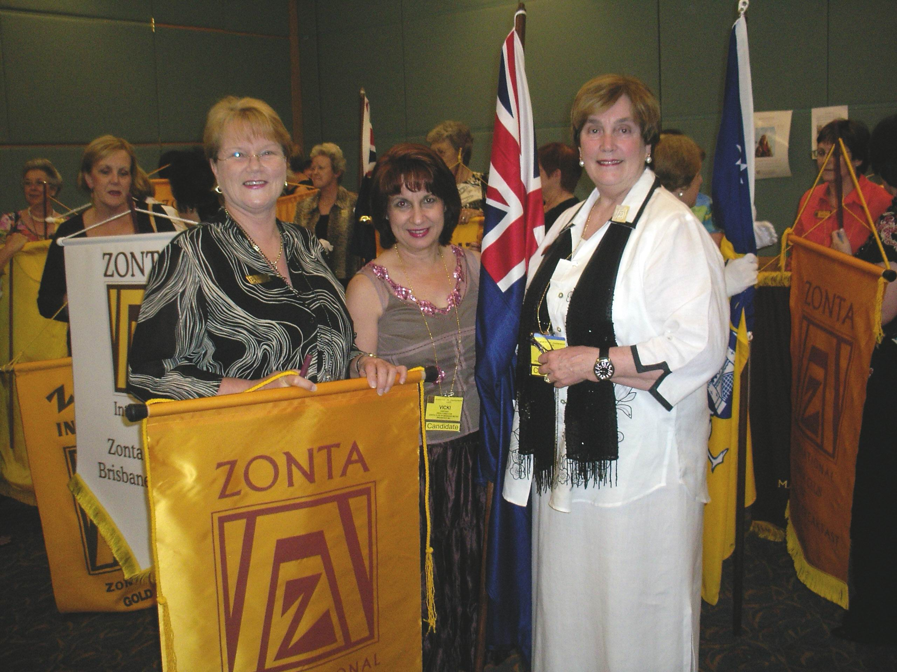

Elaine and Vicki with Patricia Lawson from the Sydney Hills Club. Patricia was elected to be District Governor for 2006-2008 and Vicki will be working very closely with her during her time as Lieutenant Governor.

- performs any duties as directed by the Governor
- is a member of the Zonta International Organisation, Membership and Classification Committee
- actively encourages formation of new clubs and recruitment an retention of members in existing clubs
- maintains contact with the district OMC committee chairman, if the LT Gov is not a member of that Committee, and with the international OMC chairman
- is a voting member of the District Board
- attends and votes a the district conference(s)

Needless to say, Vicki is going to be a very busy lady in the forthcoming years and we wish her all the best for her new role.

…..Reminder….

The Jade Buddah function is only a few weeks away. Keep up the good work in selling tickets and make sure you keep Amena up to date on your progress. Every ticket sold counts!

Happy Birthday

to this month’s Birthday Girls

Sally on 1 November

Michelle on 14 November

