
ZONTA CLUB
SOUTHERN GOLD COAST TWEED INC.
DISTRICT 22
NEWSLETTER
January 2014

P.O. Box 121
Elanora 4221
Queensland
Board Members
President
Kaye Lollback Phone 0423433813

Vice President
Susie Dunn
Secretary
Merle Stephen
Treasurer
Lesley-Anne Marsh
Director
Keri Moore

Secretary

SECRET GARDEN
SOUTH TWEED SPORTS CLUB
Monday, 17th March
5-45 pm E.S.T. 6-45 pm D.S.T
Apologies - Lesley Sunday 7pm
Email:
blacklockaccounts@bigpond

DIARYDATEs

March
17th Dinner Meeting – Knicker Night, Gold Coast University Hospital
Sexual Assult Unit
Speaker – Caroline Hastie, Aboriginal Midwife

22nd Area Meeting
April
7th Board Meeting
21st Annual Meeting - Dinner Meeting
May
5th Board Meeting
19th Changeover Meeting

Born in Ringwood lived in Bayswater, Victoria, and did my Primary schooling there, secondary schooling I attended M.L.C. Hawthorn. From school, I completed an apprenticeship in Commercial Dress design & Factory Management.

In 1956 the family moved to the Gold Coast, where I worked for my parents until 1959 when I moved to Brisbane and worked in the clothing trade until 1962. I then started the great “O.S” Trip, firstly to USA where I travelled for 3 mths, lucky to have family & friends. I changed plans when I met up with a friend who said “what about working in Canada, better pay than England” so went to Toronto and worked the Winter, yes snow for 4 mths, I had never seen snow! Had a wonderful White Christmas with family in Boston.

From Toronto I went to England and worked the for nearly 2 years, thought I should go home ,of course I went the long way (3 mths), back to see the family & friends in the States before arriving home to the Gold Coast November 1965. Working in both Canada & England was a great experience and the travel we did, loved it all, but it made me realize that Australian life & conditions were better than anywhere else I had lived & worked.

Have resided on the gold coast since then I started my own business dressmaking and worked at that until I retired 3 years ago.

Joined Zonta in1989, have held most offices in the Club and been President for 5 years, not consecutively, actually 3 different times, District Foundation Ambassador for 4 years. During my years of Zonta membership I have attended 3 International Conferences, cannot remember how many District or area meetings.

Growing up in a family who has always served the community, Salvation Army officer Grand Parents & Aunts one a missionary Nurse in Africa, helping my community as well as third world countries joining Zonta seemed natural for me to become a Zontion.
Joined Zonta in1989, have held most offices in the Club and been President for 6 years, not consecutively, actually 3 different times, District Foundation Ambassador for 4 years. During my years of Zonta membership I have attended 3 International Conferences, cannot remember how many District or area meetings.

Zonta has helped me to grow and broadened my horizons as well as making lifelong friends with similar aims and achievements.
Merle

MEMBER PROFILE
MERLE STEPHEN


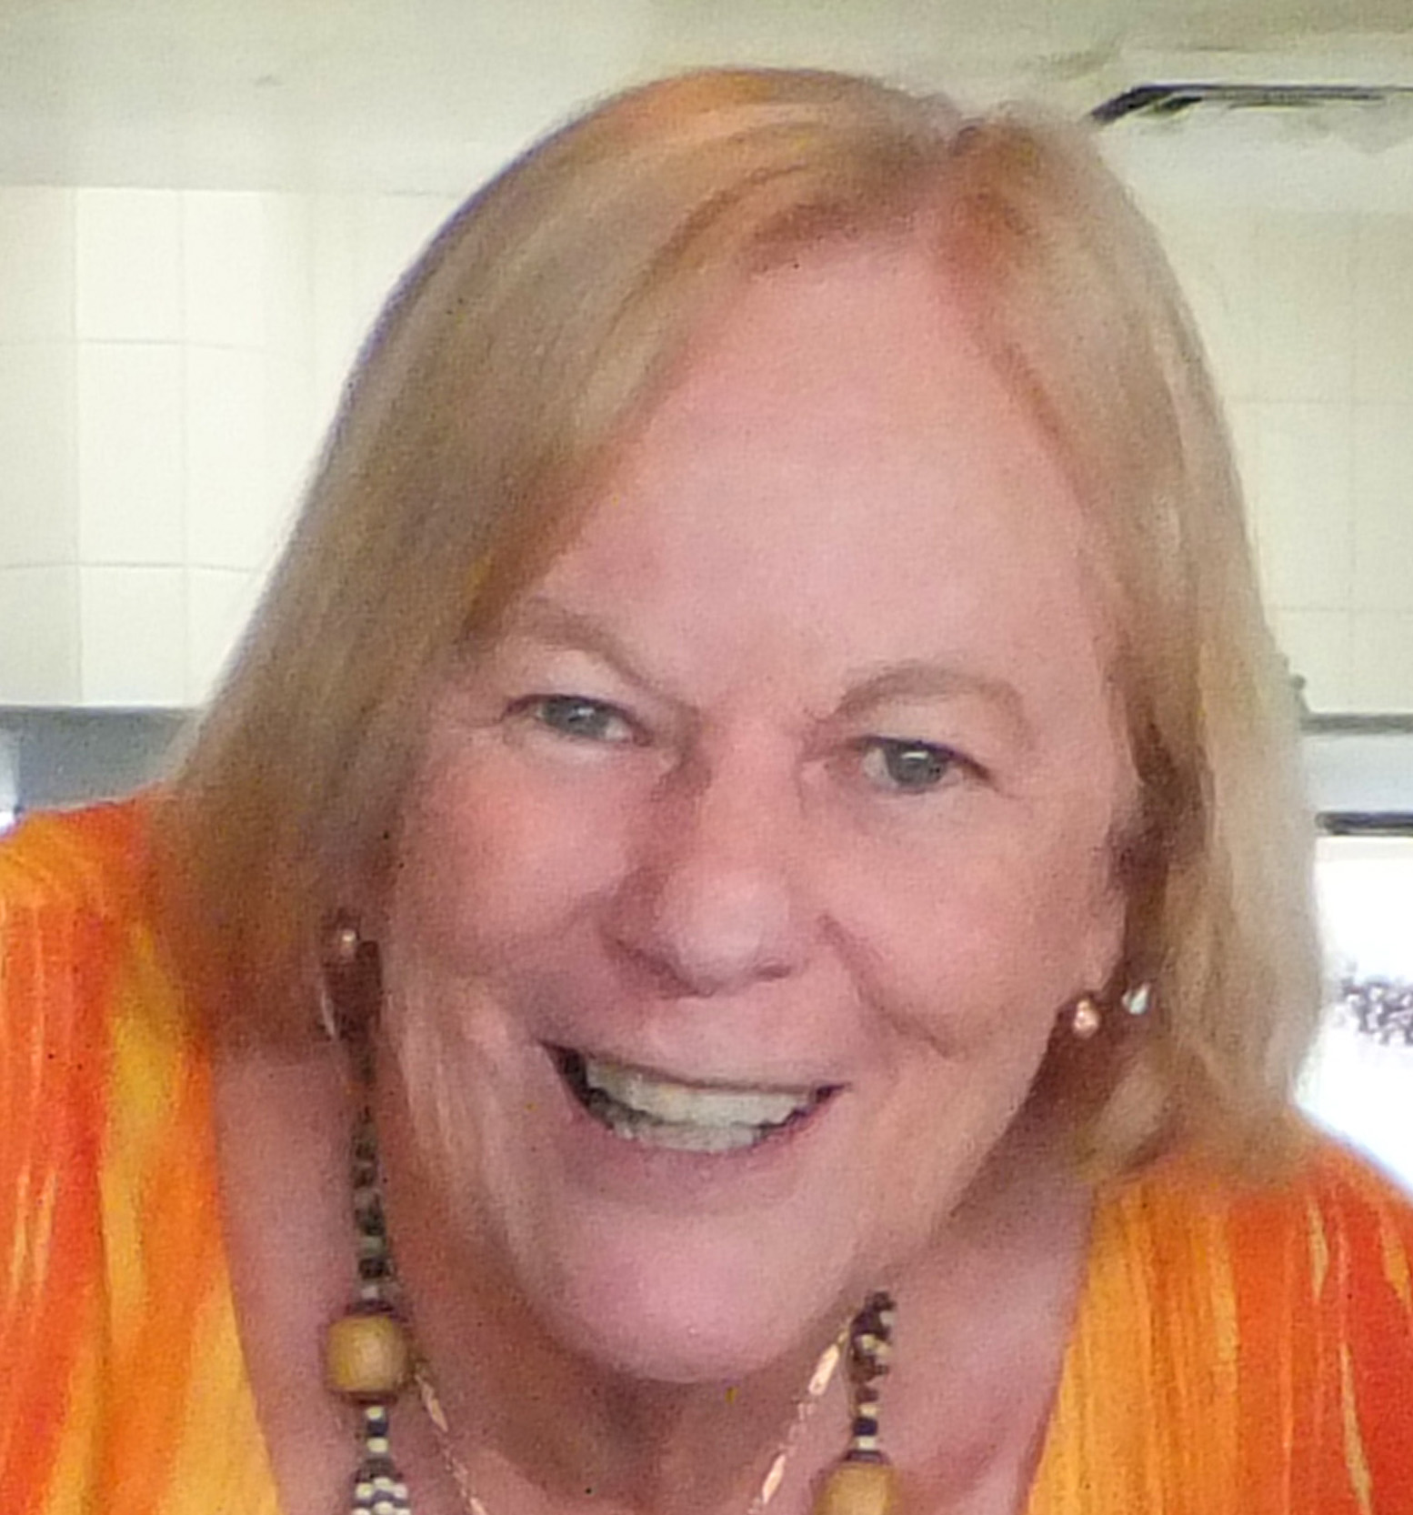

PRESIDENT KAYES
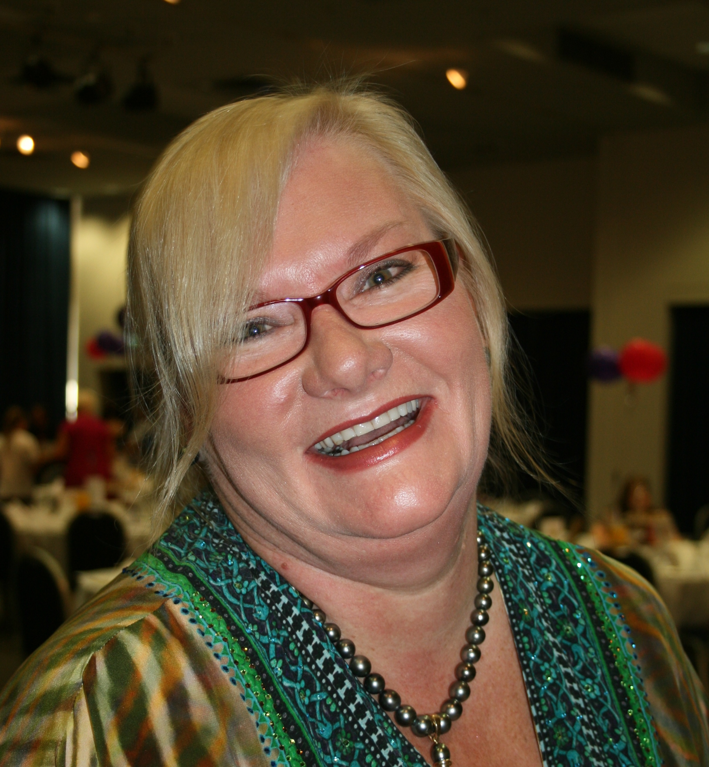
MARCH REPORT

I trust that you were able to celebrate International Womans Day and Zonta Rose Day with some inspiring company at one of the many events conducted on the Gold Coast . I must admit it did feel strange not to be holding our usual IWD Breakfast at Bond University.
The Domestic Violence Prevention Centre have mentioned holding a IWD event in partnership with our club, that is something yet to be decidedfor next year.
We are hopeful of holding another Bunning Barbeque day to help with our fundraisng efforts. Susie continues to submit request with the June –December allocations yet to be decided.
The Gold Coast University Hospital Sexual Assault Service has requested new underwear for the outpatients department. I have let April, their Social Worker know that our next dinner meeting, March 17th will be a “Knicker Night”. So consider this a “shout out” for undies. Please bring them to the meeting.
Assembly Day in April. We will be holding a demonstration on how to assemble the kits.
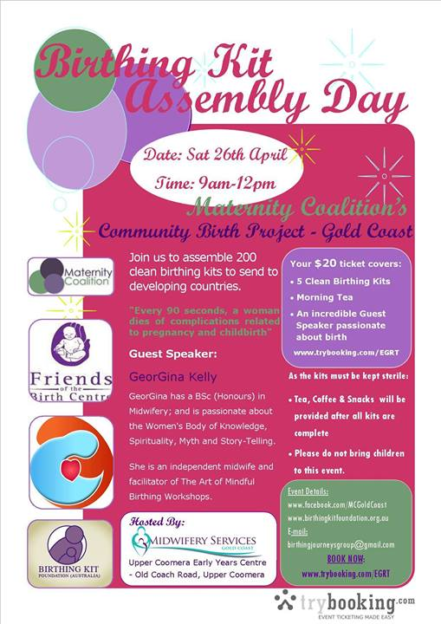

The March 17th Dinner Meeting we will also have the pleasure of hearing about Carolyn Hasties work at Southern Cross University. Carolyn is a Senior Midwifery Lecturer and I look forward to hearing of her upcoming projects. including Aboriginal Midwifery.We will also be joined by the Maternity Coalition Midwives who are conducting a Birthing Kit Assembly Day in April. We will be holding a demonstration on how to assemble the kits

Take a look at our face book page to see Zonta International President, Lynn McKenzie: sharing positive outcomes of Rwanda’s one stop centers.
https://www.facebook.com/pages/Zonta-Club-Southern-Gold-CoastTweed/152403848166376.
Also from Z.I.
Liberia: Life after Fistula
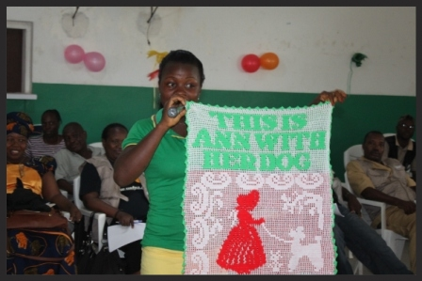
Zonta International has supported efforts to prevent and treat obstetric fistula in Liberia since 2008. Last week, Zonta International President Sonja Honig Schough visited Liberia to see how Zonta's contributions are making a difference in the lives of women living with this debilitating condition that is both treatable and preventable with access to appropriate medical care and information.

Read about Sarah, one of the Liberia Fistula Project's many success stories and watch the Zonta International website, Facebook page and Twitter handle (@ZontaIntl) for information from Sonja's visit to Liberia

Zonta Says NO results report
We Obtained our Goal!
Zonta Says NO was established to raise credibility and visibility of Zonta International with a target of 40 percent club participation. We have not only met that goal, but far exceeded it, with 60 percent of clubs participating and several districts reporting 100 percent participation.


The campaign, which gave us staggering internal and external attention, has been a significant factor in engaging our members and building connections between clubs around the world. Click here to read the full report and be sure to check out the supporting infographics.

See you on March 17th….Your’s in fellowship.
Pres Kaye.

