ZONTA CLUB OF MOUNT ISA Inc Newsletter

P O BOX 2442, MOUNT ISA QLD 4825

President: Linda Harrison Wk 4743 6733 N/Letter Editor:
Vice President: Michele Savoye Any submissions to N/Letter email to

MARCH 2005

President’s Patter

Hello Ladies,

Phew! Wot a busy, busy time. Lots going on so read on and get your fill of Zonta News.

IWD 8th MARCH, 2005
Well, IWD is over again for another year. Once again, we have excelled beyond belief. I have had people stop me in the street to compliment us on such a great function.

Everything ran well. Food was fabulous. The room looked stunning! Lauren Burns – well, what can I say. Great, terrific, enlightening……, well the list goes on!

Couple of piccies below, also check out Thursday’s NW Star to see more of beautiful ladies at this great event.

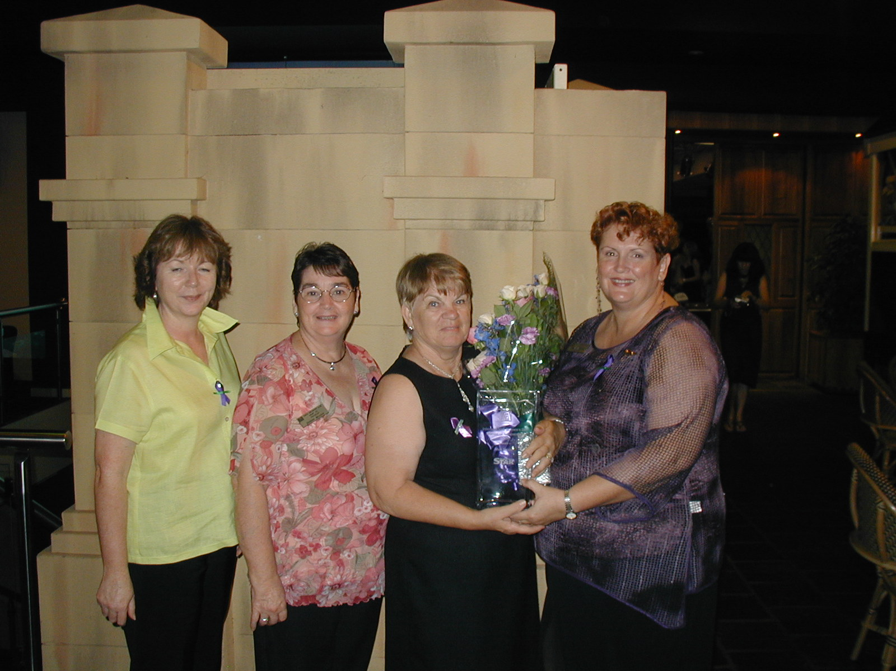

WOMAN OF ACHIEVEMENT – Sue Shield

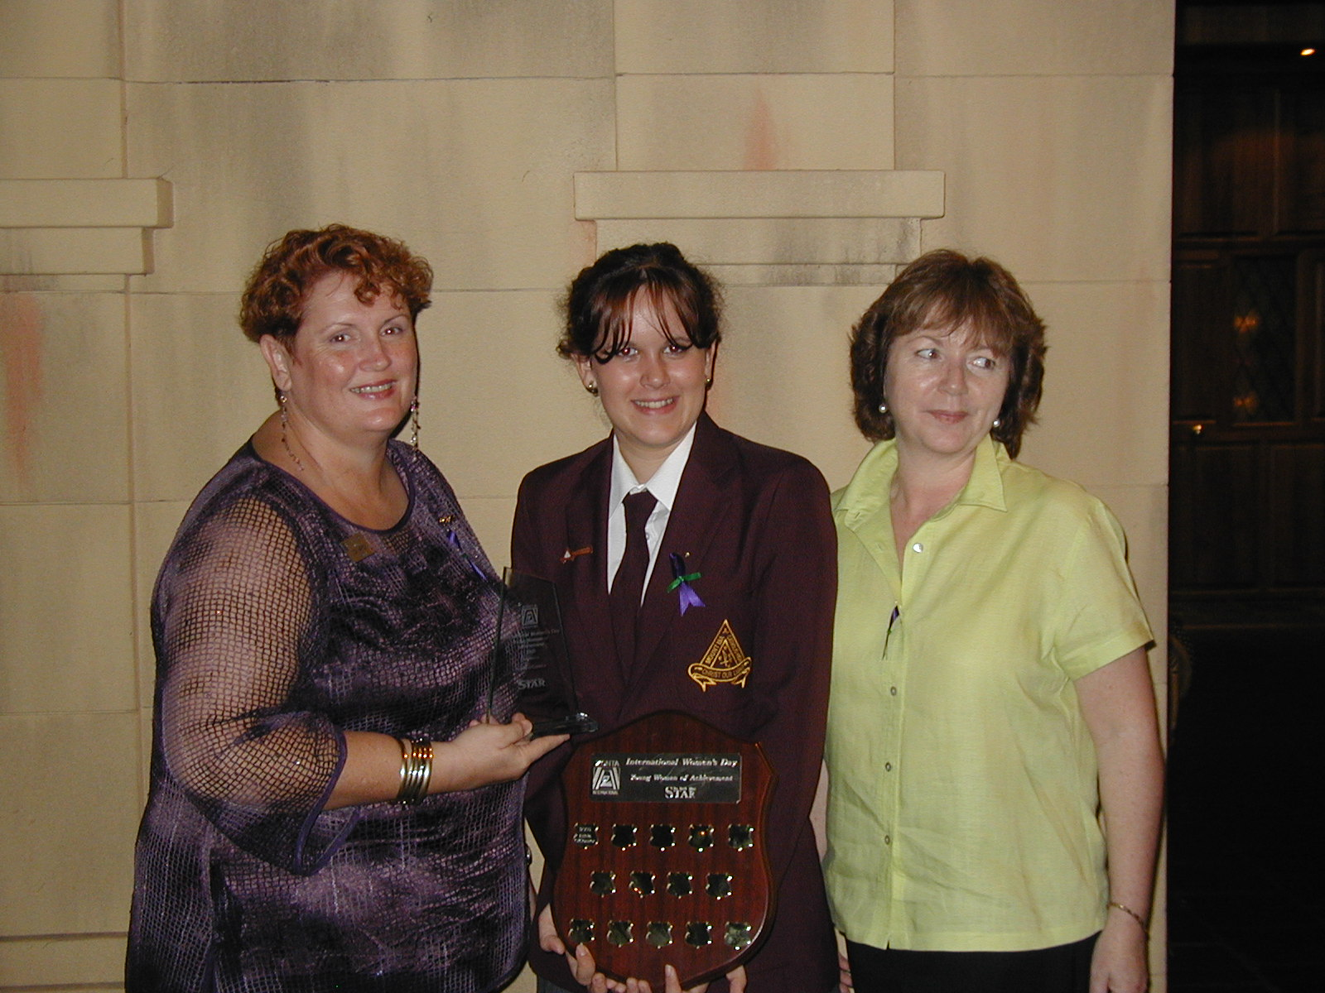

OUR YOUNG WOMAN OF ACHIEVEMENT, KRISTA O’CONNOR
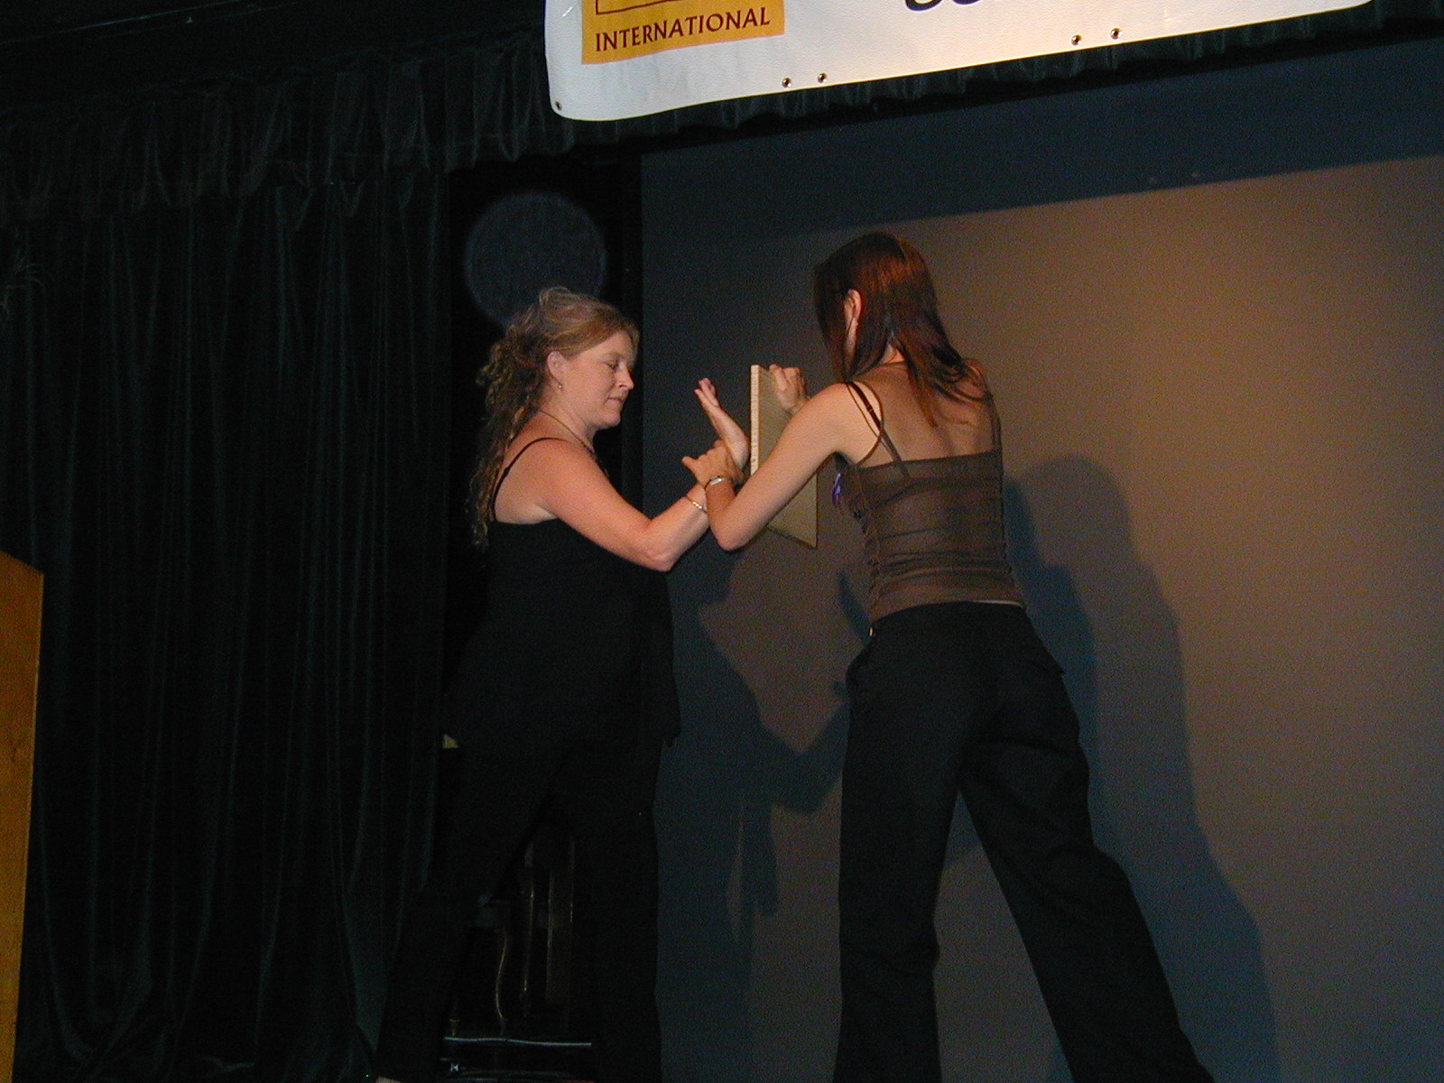

LAUREN SHOWING HOW TO BREAK A BOARD AT IWD

Obviously, I have to thank a few people (like 50), so, if I miss someone out, it’s unintentional.
The Committee’s great work!

Carolyn, for jumping in and organising Jemma’s script and, our Itinerary for Lauren on Tuesday.

Marilyn, for being soo busy at work, but still managing to be there when we needed her, onya Marilyn!

Maria and Shannon, who allowed me to boss them sooo much on Tuesday arvo and night. Thanks ladies, I know I was a lil’ Hitler.

Margot, this lady always comes to the rescue with ticket selling, and good advice and a steadying influence (particularly for moi).

Anne, Liz and our lil’ Honzon Suzie for turning up to help beautify the hall. Cherry, for following me around at the hall and finishing off what I left unfinished cause my mind wandered onto something else.

Michele, you can never leave the Club. Your door prize was drooled over by all and sundry. A truly fabulous piece. Lauren was stoked with her pottery, and was hoping to win the Door Prize as well.

Chris Gillic, who always manages to be unwavering in her calmness – if she hadn’t acted as go-between I’m sure Oliver and I would have had to arm wrestle over a couple of things.

Of course, the Breaky Club was a great boon too. Our purple and green badges were all stitched by Paula and Sue. Sue designed and made the Laurel centre piece for our tables …..
Look, if I compliment the Breaky Club this will turn into a veritable book. I’ll leave their thank yous to Jessie.

As I said, I can’t mention you all, just be aware, that we know how great you all were. It’s due to your efforts that IWD 2005 was the success it was.

Thank yous to sponsors will be going out next week, along with Nominee Acknowledgements to those who were nominated for Woman of Achievement and Young Woman of Achievement.

BOYDIES HISTORY SALE!
Dianne Hakfoort and Albert have purchased the Boyd Hotel. They are having an auction to sell of the memorabilia on Saturday, 12th March.

We are going to sell Sausages on Bread and drinks at the event. (All funds raised go to us!)
Dianne has kindly donated the drinks from excess stock of the pub, and Sonja’s going to chill them for us and supply the ice. So, there’s not much cost involved, but a great opportunity to make a few easy dollars for the Club.

Maria and Cherry will be ringing you to hit you up to work. We have 2 shifts 9am-12noon and 12noon to 3pm. Please help out, as it will be a great opportunity to sticky beak at the Boyd stuff and make some money for Zonta too.

See you Saturday!!!!

AREA 7 WORKSHOP !
Invites with Application Forms and Info packs will be posted on Friday.

Remember to hold the following dates, as it is promising to be a great Workshop. A lot of work is going into it as we speak. Dates for Area 7 Workshop 30th April, 1st May.

Next Committee meeting, to see where we’re at! Monday, 14th March, 2005 – 5.30pm at Isaco.

All those who have jobs to do, please try and have your info ready for us. Ta!

PCYC – MEGA DAY OUT – SATURDAY 9TH APRIL

Well, Mega Day out is on us again. We will be selling Fairy Floss and Ice Cups on the day. This is a combined event with the Breaky Club.

Starts at about 3pm till 8pm. Last year we worked like Trojans and sold 800 fairy flosses.

Shannon is in charge of who’s doing what, when. So I’ll leave her talk to you at the Dinner Meeting next week.

MARCH MEETING – 16TH MARCH
As it’s the day before St Patrick’s Day, we are going to have a GREEN THEME for our meeting!

So dig out your old green dresses. The FF&P committee is even trying to have Bagpipes there for our enjoyment.

That’s all for now!

ZONTA ON!!
Linda Harrison
El Presidente.

OUR BIRTHDAY GIRLS THIS MONTH IS
Carolyn Hay 3rd March
Val Ross 7th March
Liz Ryan 12th March
Maria Johnstone 18th March

HAPPY BIRTHDAY!!

AGM
The AGM will be held on the 18th of May 2005. Could all members note this in their diaries and just a reminder it is a closed meeting.

Next Meeting
Wednesday, 16th Feb
Terrace Gardens
7pm
Don’t forget to wear your St. Paddy’s Day Outfits.

“COFFEE CONVERSATIONS”

HIGHLIGHTS OF OUR MEMBERS’ PERSONAL LIVES

The February meeting was a small affair and came with the sad news that Kate Larrazabal resigned on the night from Zonta. On behalf of the Ladies I would like to thank-you Kate for all the years you have been a wonderful member, for all your work putting together the newsletter, helping out at fairy floss nights and other working bees and who could forget the days and nights you worked your little fingers to the bone making a ‘zillion’ paper origami frogs for one of our International Women’s Day Dinner table decorations. Thank-you Kate for being a good friend, committed Zonta member and we wish you well in the future. Please come and visit us as a guest whenever you can.
Has anyone noticed Alice Clarke’s new hair style?
Alice had the Ladies if fits of laughter telling us the story about her beautiful long hair that reached all the way down to her hips. Around six weeks ago Alice was lying in bed with her husband when a bat flew in and got tangled up in all that long hair. To do justice as to what happened next we will have to get Alice up to tell the story at the next meeting as she has a way with words and expressions.
The other bit of news is that Cathy Manners and her husband Merlin brought Isa-Belle Nursery. They started their first day last Tuesday so good luck and good gardening.

TO THINK IS EASY. TO ACT IS HARD. BUT THE HARDEST THING IN THE WORLD IS TO ACT IN ACCORDANCE WITH YOUR THINKING.

JOHANN VON GOETHE. 1749-1832German Poet, Dramatist, Novelist

