
July 2005

Zonta Club of
West Moreton Inc.
Inside this Issue
1 | President’s Message
2 | Zonta Events, Meeting Details
3 | Reports and Birthdays
4 | New Member Details and other events
5 | Roses and poems
6 | Fellowship in October and items for the diary
7 | Area Directors’ Report
Our Club Website :

http://westmoreton.
zontadistrict24.org/

Zonta Club of West Moreton Inc.
PO Box 505
Ipswich Q 4305
Club No. 0900; District 24; Area 6

President’s News
.
.
.
Zonta Newsletter
From President Leonie
This last week has certainly been very Zonta focused for me, commencing with the board meeting last Monday. Mary Ellen Bitner’s speech on Wednesday night was inspiring, and really a revelation about the international programmes, the criteria by which they are selected, and the monitoring which goes on. There was absolute silence in a room of 200 women while she spoke, such is her charisma. To quote from her speech ….”we are the organization of women who work to make life better for all women…..” Her speech will be available shortly, and I encourage everyone to read it.

On Saturday I attended the presidents’ meeting at Diana Douglas’ home beyond Oakey.
The day was a steep learning curve for me, in an environment of encouragement and productive discussion. Ideas and problem solving strategies were exchanged, which I know will be invaluable to me.

On Sunday, of course, was the Heritage Homes Tour, which was so ably organised by Pam and Bev, and supported by the wonderful team of sandwich makers, loaf butterers, morning tea and lunch preparers and servers, tour guides, cake and slice makers, and all the other folk, including daughters, friends, and husbands who so willingly gave their time. A function such as this is such a team effort, and the high standard which is achieved year after year is to be commended.
The generosity of the home owners in allowing us to view their beautiful homes, and the Ipswich City Council’s assistance in sponsoring the buses, and providing bottled water and memento lapel pins, enables us to continue to raise funds for our projects, and to highlight this wonderful city of ours to the 100 plus people who came along on the tour.

I look forward to inducting 2 new members next meeting. New members ensure the continuity of Zonta, not just at local level, but worldwide, so that we can continue to make a difference.

Leonie

JULY MEETING DETAILS

MONDAY 25th July
6.15pm for 6.30pm
at The Ipswich Club

Speaker :
Carla Klease - Barrister-at-Law, Caxton Street Legal Centre

Dinner Cost - $22 per person

IMPORTANT :

Please phone Vicki Doig on 3812 8009

please also indicate if you are bringing a guest
or with apologies
or any special dietary requests
(e.g. a vegetarian meal)
before 7.15am Friday 22nd July.

REMINDER: If apologies are not received by stipulated time of the meeting week, you are required to pay for the cost of the dinner. The Treasurer will send you an invoice.

Door Duties : Vicki and Gillian
Speaker Introduction : Jennifer
Speaker Thanks : Pam VdeH
Grace & Toast : Carolyn

.
.
.
.
Zonta Events

Date : Monday 25th July
6.15pm at The Ipswich Club
Zonta Dinner Meeting

Date : Friday 12th August
Newsletter items Due – to Sue Hutley. Phone through your news on 3202 3436

Date: Sunday 24th July Toowoomba Club’s Quilt for a Cause

Date: Sunday 7th August – 10am to 2pm
Zonta Club of Brisbane East’s Antique and Collectables Charity Fair. Jindalee State School Hall, Wongaburra St, Jindalee. $4 entry.

Date: Monday 29th August
6.15pm at The Ipswich Club
Zonta Dinner Meeting

Date: Sunday 25th September 2005
Toowoomba Garden City Club’s Jazzfest in the Garden

Date: Saturday 1st October Cambrian Evening – see details this newsletter

Date: Friday 7th – Sunday 9th October
Gold Coast
District 24 Conference
Zonta – Making a Difference
June 24-29, 2006
Zonta’s 58th International Convention - Melbourne



Reminder :
AN INVOICE WILL BE AUTOMATICALLY SENT TO MEMBERS FOR THE COST OF THE DINNER IF THEIR NAME IS NOT ON THE APOLOGY LIST.

Heritage Homes Tour
What a Great Day !
Congratulations especially to Pam Lane and Bev Johnson and to all of the helpers and tour guides.

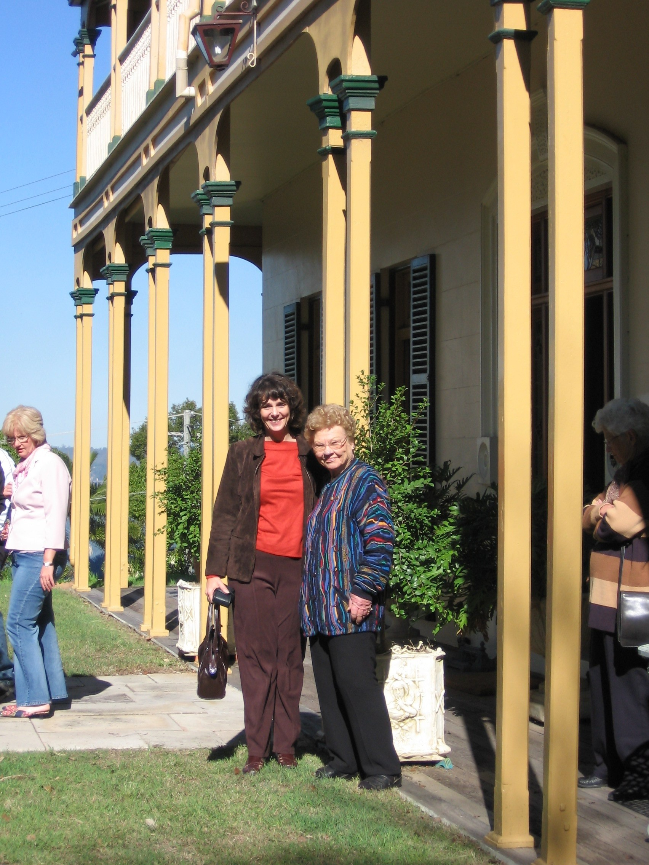

United Nations
2005 is the Year for Microcredit
http://www.yearofmicrocredit.org
and also the World Year of Physics 2005
The international physics community is celebrating the 100th anniversary of Albert Einstein's "Miraculous Year". Within only one year, 1905, Einstein framed three fundamental theories in physics: the relativity, Brownian motion and quantum theories
Zonta International Service Project : HIV/AIDS and Poverty
CARE International Mata Masu Dubara (Women on the Move):
Microcredit and Health Education for HIV/AIDS -Affected Women in Niger

UN Committee Report:
In the true spirit of the UN which seeks equality for all, our Committee has decided not to have a designated chairman and, in the words of Cheryl, have declared ourselves to be a Round Table Democracy.

Following suggestions from the club at our last meeting, we shall endeavour to highlight UN matters, including those of the environment, in each newsletter. Some of the events we have also discussed are whether or not to go ahead with the Spring Walk for UNIFEM in September (Sheila is investigating the availability/suitability of the Denmark Hill Conservation Area for our picnic) and our continuing participation in the Clean Up Australia Day next year. As there has not been a large response from members for either of these activities we all need to decide whether to go ahead with them.

We must thank Margaret for finding a really interesting guest speaker for UN Day 24 October. She and/or Robyn can tell you all about her at the next meeting.
Put on your thinking caps for things you would like us to do. (We won't forget the whales).
Margaret, Robyn, Sheila, Cheryl and Maria

9 August
International Day of the World's Indigenous People
12 August
International Youth Day
23 August
International Day for the Remembrance of the Slave Trade and Its Abolition
8 September
International Literacy Day
16 September
International Day for the Preservation of the Ozone Layer
21 September
International Day of Peace

Committee Report : Program
Update report from Programs …
We are busy trying to assemble an interesting and varied program of speakers for the year, commencing with an award-winning barrister involved in community work with women and the homeless, Carla Klease (July 25th) and Gary Whyte from Ipswich City Council talking about the new Development Plan for the region (on August 29th.) We are eager to hear other suggestions from members!
PLEASE NOTE : We will be nominating members for the introduction of speakers and vote of thanks on each occasion (in the newsletter) commencing with Gaye Anderson (intro), Joie Dwyer (vote of thanks) and grace and toast (Vicki Doig) for the August meeting. Please say yes, but if unable, please find someone to take your place!
Thanks ,
Pam van de Hoef (Chair)

Membership Committee Report :
The Zonta District 24 Focus for this biennium is to achieve a 10% growth through retention & increasing the numbers of new members, which will be the club's long term goal! So, it is with pleasure that 2 new members are being inducted at the next meeting Alison Teves & Tina Kelly, who have been approved by the Board. It is a protocol of the club to inform membership of new incoming Zontians. Should there be any dissention, please advise by Wednesday 20th to Gillian Wilton.
This year regarding keeping our members happy & looking at the comments of the recent survey, we are looking at more fellowship. See the Cambrian Evening in August elsewhere in the newsletter. Your committee is looking to encourage new members from categories not yet represented in the club. So we are looking at pharmacists, lawyers & journalists. To encourage younger members, your committee is out there networking. Vicki & I will be wearing our Zonta badges at the Ipswich Chamber of Commerce Breakfast for a start. Those other Members who attend these Chamber meetings, I hope will also be wearing their Zonta badges!!!!!
We want you to feel part of the Zonta Membership, so if you have missed more than 2 meetings, we will be touching base. New members will be having a mentor. Finally, keeping track of the numbers for the Monday Club Dinners, for those of you who have done it in the past will know, is stressful as the numbers never gel! So please help us by observing the new protocol & having your life organised (we are the organisation committee!) at the latest by 7.15 am the Friday prior to the Dinner Meeting.
Gillian, Myrtle & Vicki


Zonta Club Birthdays
Many Happy Returns in July
to: Joie
Many Happy Returns in August to: Leonie
[ Did we miss your name? Please contact Eirys to confirm your birth date for our records]

New Member – Alison Teves
(to be inducted in July)


Alison Teves prides herself on the ability to balance work, family and personal quality time. I have a 19year old 2nd year at UQ, St Lucia and a 17 year old in Year 12 at Ipswich Girls Grammar School. I have recently become engaged however no dates have been set for a wedding as yet. I really enjoy (trying) keeping fit. I attend a local gym as well as running occasionally with my children. Another favourite pastime is boating and have just become a proud owner of a small boat with my partner. In my spare time I am studying Frontline Management.

As the General Manager of Heritage Business Services I lead an extremely motivated and dedicated team of recruitment consultants who work in the professional, executive, administrative and blue collar areas. I am currently involved in developing a new business unit which offers Management Packages to businesses via the internet. This is a very exciting time for business growth.

From Toowoomba…

ZONTA’S
QUILTS for a CAUSE

AN EXPO OF QUILTS

BROUGHT TO YOU BY
THE ZONTA CLUB OF TOOWOOMBA AREA INC.

SUNDAY JULY 24TH

10.00AM - 4.00PM

THE GLENNIE ROOM
GLENNIE SCHOOL
HERRIES STREET TOOWOOMBA

ADMISSION $10

ENQUIRIES
TwBa Club Members
VICKI 0412360197
HELEN – 0403005943
AMANDA - 46323812

Save The Environment

National Tree Day – Sunday 31st July - is Australia's biggest community tree-planting event. Visit http://www.planetark.com/
for more info. You can buy Tree Day Backyard packs from Coles.
Join Greening Australia at the Blue Gum Reserve, Karalee on the day.
Also, please visit http://www.amp.com.au and click on the Platypus to support Landcare's Project Platypus.

For every click that you make, AMP Foundation will donate $1 to this project (up to $10,000).

A poem found by Vicki …..

Volunteers at Work
It’s not for the money,
It’s not for the fame,
It’s not for any personal gain,
It’s just for the love of fellow man,
It’s just to lend a helping hand,
It’s just to give a tithe of self,
It’s something you can not gain by with wealth,
It’s not for the feeling deep inside,
It’s that reward down in your heart,
It’s a feeling that you’ve been a part,
Of helping others far and near,
That makes you a Volunteer.
Anon.
Rose Advice
from Pam VdeH

We have a yellow Zonta Rose in our front yard. We also have a Double Delight (red and cream), a Mr Lincoln (red), a just Joey(apricot/cream) and a Princess Elizabeth (pink), all in a row. They have all flowered, and all withstood considerable neglect, followed by guilt driven mulching and fertilising that is the hallmark of gardening at our place. The flowers have brightened our kitchen amid the clutter of school newsletters and junk mail. The row in which they stand was a cause for hilarity for my husband, as he discovered that the mud map of where the water pipes are at our place was just that little bit inaccurate. We have been married for 25 years, and may even make it to 26 years.
The pink rose was a gift from my children for Mother's Day, the Double Delight reminds me of a work colleague who frequently had them on her desk as she helped me, Joey reminds me of friends in Ipswich who grew it and stepped in to hang curtains and paint when we moved to our new place, and the deep red one reminds me of our friend who got cancer at 50, and retired to smell the roses.
The Zonta rose bush is small, a bit bent and imperfect in places, but tough and resilient, and produces wonderful roses often, without scent and without too much fuss. It reminds me of you all.


Zonta Roses on Order
Zonta Roses will be available at the end of July. We are awaiting a delivery date from the nursery. The cost is $15 per rose. Gillian will email or telephone the Zontians who have ordered as soon as the roses are available. You will need to collect them from Gillian at work - 102 Limestone Street, Ipswich. (Tel 3281 7611). Orders are currently in for :-
Glen Walters, Helen Walker, Joc Steele, Sue Wrigley, Dianne Maccheroni, Maria Kelly, Carolyn Maddox, Joie Dwyer, Margaret Evans, Gaye Anderson, Maria Stevenson, Sue Hutley, Sheila Ireland (2), Margaret Boulter.
SO DIG THOSE HOLES FOR THE ROSES!

Surfing the ZontaNet

Don’t forget to log on to our club website, district website and the international websites regularly….

The district website address has now changed to
http://zontadistrict24.org/
you will need to join this website and select a username and password.

Sue Hutley (our webmistress) has recently updated our club site at
http://westmoreton.zontadistrict24.org/
so please take a look and see what you think.

The International site at http://www.zonta.org/
requires the username and password from your Zontian magazine.

If you have any questions or problems with the websites please contact Sue Hutley and she can talk you through it over the phone.

October Zonta Fellowship Event

Cambrian Choir – Theatre Restaurant

“Some Enchanted Evening”
- songs from the musical

Saturday 1st October

$28 per ticket

Please contact Eirys for tickets ASAP
2004-2006 Zonta
Biennial Goals
- Focus on our Mission
- Combine Service and Advocacy
- Recruit, Retain, Rejuvenate

Zonta Badges

Don’t forget to wear your Zonta badge …. everywhere ! ☺ ☺

For Your Diaries –
Meetings Dates 2005:
25th July
22nd August
26th September - Birthday Dinner
24th October- United Nations
28th November - Business meeting
12th December - Christmas Dinner

Zonta Grace

For life and fellowship and food
For all good things in which we share
Father, we thank you for the good that
Zonta stands for everywhere.
Grant us the peace that comes from You
To sanction all we say and do
Amen

