Dinner Meeting:
Contact Diane Woodland - for all dinner arrangements no later than the Monday prior to our dinner meeting. Advise her of any apologies if you are unable to attend or to let her know of extra dinner guests that you have invited.

COST (Includes dinner) Members/Guests $20.00

Special Dietary Requirements:
If anyone has any special dietary requirements will they please inform Diane so that she can inform the club. The club is very happy to cater to individual needs.

Dianne Woodland

Home: 3289 4995
Mobile: 0409 726 600
Email: dkinta@tpg.com.au

As it is assumed you will be attending all meetings of the club unless an apology is received, any member from whom an apology is not received in time will still be invoiced for the meal ordered for her.

DIARY DATES

- 10th June – Dinner Meeting at Arana Leagues Club 6.30pm

for this month goes to….

Rosalind Pestell 8th June
Vicki Williams 23rd June
Janet Hayward 25th June

Bingo Report

PLEASE TAKE NOTE OF ANY CHANGES TO THE ROSTER.

Volunteers please arrive at 9.05am to set up.

Bingo Roster

June 4th Jan
Wednesday 11th March
Arana Leagues Club
11th Carol
18th Diane
25th Kay

July 2nd Tracey & Laurie
9th Bettina
16th Carole
23rd Karen
30th Vicki Bell

August 6th Jan
13th Rosalind
20th Diane
27th Kay

Sept. 3rd Bettina
10th Carole
17th Karen
24th Tracey & Laurie

Oct. 1st Rosalind
8th Vicki Bell
15th Diane
22nd Kay
29th Bettina

Nov 5th Jan

As usual, I have tried to fit in with everyone’s plans and holidays. I hope this is ok with everyone.
Vicki Williams Bingo Convener

Following are
reports from the
Zonta Annual General Meeting – 2009:

President’s Report 08/09

I would like to thank all the members of this club for the honour of being your president
for the last 2 years.

Although I had been a member for many year I never had any aspirations to be anything else, and on saying that I did do the newsletter for many years, and treasurer for 4, also Service for 2 years so now I intend to sit back and enjoy talking to everyone, as the hardest part for me was sitting on the head table.


My many thanks go to the board, for their excellent hard work, Lorraine as Service Chairman, Tracy as Correspondence Chair, Suzanne- the best Treasurer, Janet who managed to get us
lots of publicity and exposure, Simone for all the hard work in Finance and graphics for
our functions, Laurie for UN information, Roz for her committment to records and new members and Vicki for the weekly bingo, and you all for your support of our functions.

Although our functions were not great in the fund raising stakes, we did get a lot of profile and some new members from our efforts.

I wish the new board all the best for the coming 2 years and pledge my support to you my club and all their endeavours.

Regards,
Jan Spittle

Status of Women Report

Many thanks to the Status of Women committee for their support and helping to decide issues that impact on where our hard-earned dollars are spent through the year. We have continued this year helping Jebb House, a domestic violence refuge for women and children with manchester, utility kits, school satchels and underwear for the women who arrive with virtually nothing. Jebb House co-ordinator Stacey, has always emphasized their appreciation for our help. In particular, the women who leave to set up their own home, usually with very little belongings, are quite in awe that someone actually cares enough about them.

Clyde House became self supporting last year and we have now directed our help towards a new Lions Life Skills Centre (under the umbrella of Integrated Services) established for women with young babies or children and which is still in its infancy. As they discover their needs, they know that we are willing supporters.
Unfortunately the five Bursaries for secondary school students weren’t availed of at the end of the year which has resulted in a change of direction for our club. We will now offer a $2000 Bursary to a female disadvantaged university student commencing at the beginning of 2010. Along with that change, the club has decided to offer five smaller awards of $100 to disadvantaged Year 12 female students in the form of a book or voucher as an incentive for them to continue their studies. This will be implemented at the end of year awards to students at Speech Night.

Pine Rivers Neighbourhood Centre has received $2000 for the running of two ‘Healthy Relationships for Teens” courses for secondary school students and Caboolture Regional Domestic Violence (a non funded organisation) received $900 for printing of brochures to be distributed.

Again we sewed breast cushions for cancer patients and packed Birthing Kits for delivery to overseas destinations. These two events remain a wonderful social interaction for the club and will continue. Dr Lara Wieland remains our contact person for the support we give each year to the Townsville camp for school children from Kowanyama, and the $2000 this year was appreciated as an inducement to better behaviour and school attendance. Reports after the camp have been quite supportive of the results they see. We continue to send parcels of second hand clothes to Kowanyama which is appreciated by the women.

Again we celebrated International Women’s Day with a charity lunch with profits going to Sue Kupiac’s orphanage in Nepal and also UNIFEM. A number of toiletry bags were made up for Homeless Connect, a bi-annual event held at the City Hall to bring together the homeless of Brisbane to show them what support is available.

All of this work represents the efforts put in by members of our club. Working together we make all of this possible and I would like to thank everyone for their support.

Regards,
Lorraine Hunter

Organisation, Membership & Classification Committee Report

I remain grateful to Penny for all the work she did for the Club as the only member of the membership committee (apart from myself) before she resigned from the Club in March 2009.

Membership Numbers and changes:-
Following the April 2009 induction of two new members, Fiona McNamara and Glynnis Gartside (who comes to us from the Bundaberg Club), and the re – joining of far from “grey” nomad Vicki Bell, the Club membership at May 2009 stands at 26.
At the end of May 2008, we had a membership of 27.
During the 2008- 2009 year, Rhonda Horne who had been on leave of absence and working in Qatar for the Education Council, briefly returned to the Club. Rhonda has since resigned from Pine Rivers as she intends transferring to the Zonta Breakfast Club of Brisbane which suits her work timetable better. Meanwhile Jenny Leggo continues on leave of absence but remains a financial member.
Alison Ahern, Penny Garnsworthy and Elizabeth White all resigned recently in order to make time for family responsibilities and other interests. They were all excellent members and we were sorry to say good-bye to them, and wish them well.

As required by Zonta International’s “Diversity of Classifications” By-Law, the Pine Rivers Club’s members are actively engaged in a variety of occupations. The Club’s 26 members are classified in 23 different occupation codes. This includes 5 members who are education professionals but whose current positions or occupations are different from one another, and 4 business managers/owners/directors.

Members’ profiles
The monthly member’s profile in the newsletter continues to work well, and I thank all the members who have shared a little of their lives with us this year.

Finally, thank you to Jan, Vicki, Janet and Simone who continue to spread the word about Zonta through newspaper columns, Zonta banners and adverts, and responses to emails, and to every member who keeps her eyes and ears open for possible new members.

Regards,
Rosalind Pestell
Finance Report
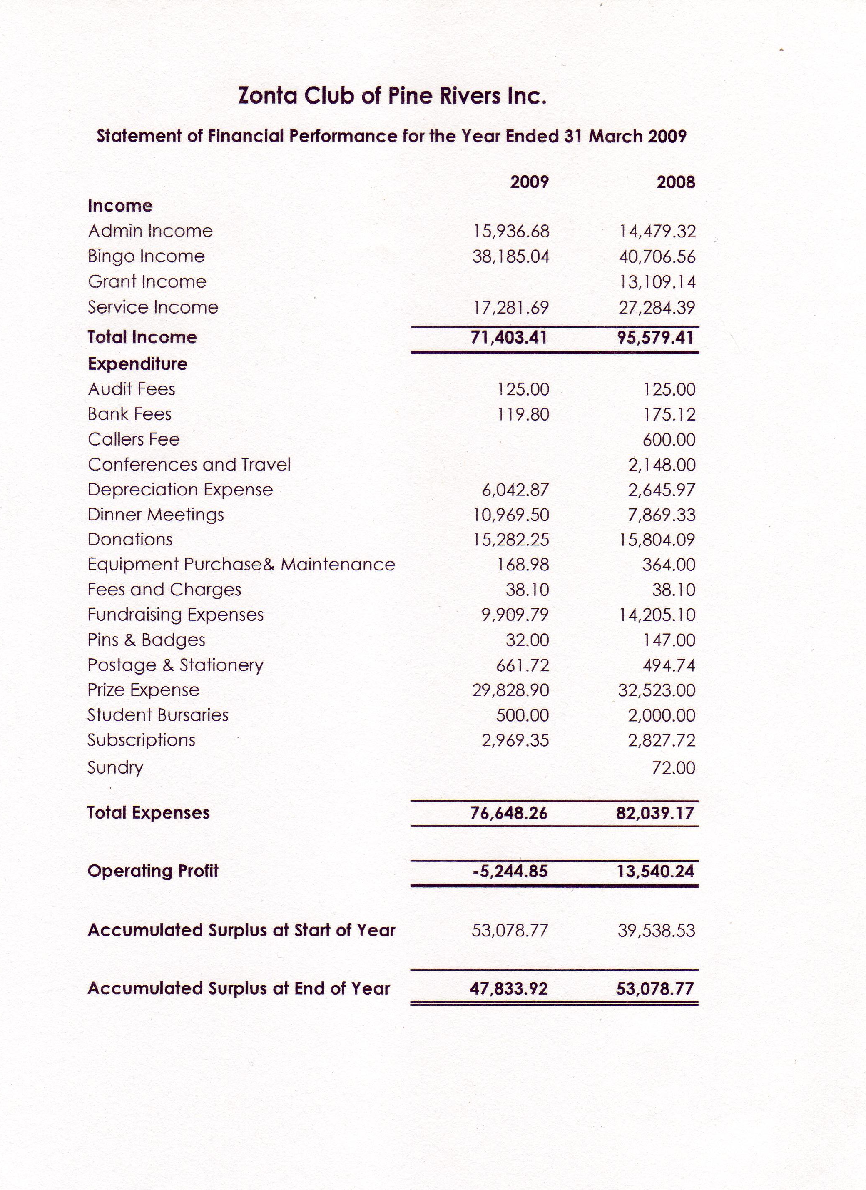

For full report and all financial details see the Annual Minutes.

Suzanne Strahan
Treasurer
New President’s Message

Being the beginning of the new term for our committee, I must say a special thanks to Jan for two years of hard work for our club and that now it’s time for her to relax at the meetings and enjoy another aspect of being a member of Zonta once again, albeit a special member!

Our new committee – Tracy, Dot, Karen, Melindie, Janet and Suzanne are all excited (I think) and looking forward to the year ahead. We have for the first time in a number of years a Melbourne Cup Day function to organise and Lawrie Krause, our United Nations representative, is looking at a way to celebrate United Nations week later in the year. Any ideas are welcome for both events.

Our speaker at the May meeting, Noreen Harris was an exceptional lady and Tracy has given a great summary of her speech in the Minutes for those who missed the last meeting.

Lorraine Hunter
President

Th
Membership
Profile

This month’s profile is from our new Vice-President Tracy Watson. (Thank you very much, Tracy). You will see from Tracy’s super profile she doesn’t do things by halves! Her life experiences are many and very diverse – and as for moving house, she must hold the Club championship surely. Can anyone beat 25 times???? (and that doesn’t include moving to Australia).

Tracy wouldn’t want me to portray her as wearing a halo but I think she epitomises the type of woman who makes an excellent Zontian. Despite being very busy in her personal and business lives, Tracy joined Zonta in early 2007, shortly afterwards took on the role of Minutes secretary, quickly got very involved in the Club’s projects, especially fund raising ones with Simone, and the money side of bingo with Vicki, and has now accepted the Vice President’s role. She’ll be staunch support for Lorraine and the new Board and an excellent Service Committee Chair. (And I admire and envy her fashion sense - she always looks fabulous).
Ladies, I give you our Vice President’s profile ……..

Regards,
Rosalind Pestell

Tracy Watson

I grew up in a small village called Church Lawton in Cheshire UK. We lived in a 200 year old home converted from stables and servants quarters, with a cobble stone back yard and an old mud filled well.

I lived with Mum, Dad, my younger sister and brother, my cats and my rabbit.

My biggest move (home –wise) to date was when I moved to Australia at 14 – of course, I felt my life was ruined – but later adjusted that belief and became a proud Australian. We were the last of the ten pound passengers in the mid seventies and travelled 5 weeks by ship via The Canary Islands and South Africa, which was an amazing experience .
We settled in Sandgate and I was enrolled at Sandgate High, where I survived the culture shock and completed my senior education. I guess that I adapt quite well to change, which is lucky as since arriving in Australia I have moved house 25 times. My builder husband and I joke that we have actually now unpacked the boxes at our home in Samford, where we have lived for an astounding 4 years!

People/pets and possessions dearest to me now: My husband Tony, a grounded country boy from Mitchell, whom I met whilst studying at the DDIAE in Toowoomba.
Three children - Amy (27), Dane (25) & Sarah (22), all of whom I intensely encouraged to head out and explore the world whilst they were young – then became quite sad when they all left home to live overseas, all within 1 year!
My faithful 13 year old Cocker Spaniel, Freddie. Buster our big, handsome & very energetic curly coat retriever x lab.
Goats; Matilda and Sponge Bob, Duck; Dark Wing and The Girls; our chooks.

My business or profession is: My goodness, I have worked in so many areas – how many profession changes do they say people should have? I studied and worked as a Primary Teacher, a profession which I am now quite tempted to return to. I spent 3 years (2 as a student) at Baillie Henderson Psychiatric Hospital in Toowoomba prior to family, then, I trained as a travel consultant but have never actually worked in the area. I purchased a Surf Shop and learnt about marketing, teenagers, skateboards and shoplifting. I became a facilitator sourcing employment and re training long term unemployed youth and I packed up the car as a school based rep for Ashton Scholastic educational products. Plus….. there were lots of part time jobs… from cleaning and waitressing to selling Amalgamated Pest Control and Tupperware!

My current work or main occupation is - I work with my husband in our building company where I manage the business side and work on design specifications for spec homes.

My other interests and/or skills and/or indulgences are camping and hiking.
Live music, whether it is classical, rock, jazz, new age, musicals etc – I have a very eclectic taste.
I am definitely a food and wine junkie.
Travel - always organising our next venture.
I love to learn, and am most content with a book (or any written medium) I also love to smell new books – which sometimes draws a few strange looks!

I also want to tell you that: I became a proud Australian citizen in 1992 - my husband gave me a gift of a pair of red thongs (I never wore thongs) and my mother gave me a Union Jack (just in case I forgot my heritage!)
I was the Girl Guide Leader in Sandgate for 4 years with a big focus on outdoor skills.
I have had flying lessons and wish that I could have continued – maybe later!

Year joined Zonta: I’m shocking with dates but the membership list says I was inducted in July 07.

I joined Zonta because: Firstly because I strongly believe that each and every person has a responsibility to give service, of some nature, to both their own and wider communities. Secondly, we had recently moved from Sandgate to Samford and I wanted to meet other like-minded women.

I remain in Zonta because: I enjoy it!

Positions held in Zonta: Secretary and now Vice President.

Positions I’d be willing to try sometime: “Never say never” – so possibly any position.

Extra Diary Dates…..
AREA
WORKSHOP
21st March 2010
Maroochy and Blackall clubs are going to be the hosts.

DISTRICT CONFERENCE
25TH – 27TH September 2009
at Rydges Southbank, Townsville
Keep an eye open for good air prices!!

International Convention 2010
San Antonio, USA

International convention 2012 Italy

Courtesy VICKI (Area Director)

