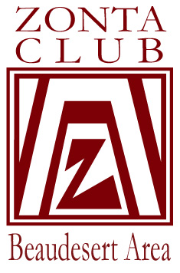
ZONTA CLUB OF BEAUDESERT AREA INC. CLUB # 1197

BeauZontian
P.O. Box 174
BEAUDESERT 4285
AREA 3 DISTRICT 22
ISSUE: 274 DATE: November, 2011
Words from our President Denise Martin:

Well we certainly had a busy Board meeting last night and that can only have repercussions for all of us! It is such a busy time of year and of course, there are our personal lives to fit in as well.
First with the exciting news; Margie’s committee has managed to secure an exciting speaker for IWD – Zelie Bullen. Zelie lives at Canungra and recently her story was on the ABC’s Australian Story (you can google it). In short she has been a stunt rider at Warner Bros on the Gold Coast and now mostly does animal training for films, recently working in London on Steven Spielberg’s “War Horse”.
(p.s. wrote this on Tuesday night and bang..on Wednesday her profile is in the Beau Times.)
On more immediate matters, the Garage Sale is coming up this weekend. Set up work will begin at the Baptist Church from 1pm on Friday. Sharon has a ute and help so she will pick up bulky items – contact her on 0400580223. Saturday will be an early start; some will need to arrive at 5:45am to carry the setup tables outside, put up the Zonta tent and open the gates as soon as we can for those who want to support our fundraiser. We hope to be all done and dusted by 12:30 and needless to say, if your Honzon or Friend of Zonta wishes to lend a hand we would gladly accept.
Volunteers are needed to sell tickets for our hamper baskets to be drawn at Gourmet Goodies stall on 3/12. We have a ticket-selling table outside the chemist in William St on 17/18; 24/25; 1/2 and at Tuesday’s meeting a roster will go around.
Please bring your donations for the baskets to the meeting or drop them into Alice’s office ASAP.
Also at that meeting we will be having a “working bee” of stamping/separating the raffle tickets – bring a stapler along. A second roster will be for times at the actual stall on the Saturday. I think you all know what you make successfully and we look forward to our usual successful event.
Other up-coming events:
- 3 or 4 people from 4-8pm needed to assist at the Centacare Christmas party on 19th November. We did this last year and it was a successful fundraiser for us and helped Sharon’s mob out at the same time.
- Carols in the Park on 7th December – a couple of Contains to hand out song sheets.
- White Ribbon Day on 25th November. We would like to make this a significant event with the launch of our Calendar so we hope as many Zontians as possible will be there and also HonZons as well. We already have quite a lot of councilors and welfare agencies committed to attending.

Last but not least is the Christmas Party on Sunday 27th. It will be a lunch at Pennie and David Hammond’s place and another roster will circulate with what you will bring to the lunch. This is always a lovely afternoon and one of the few occasions we get together with HonZons.
I told you it was a busy time! I want to thanks Alice in advance for chairing the meeting on Tuesday night as I will be away for a few days.
Yours in Zonta,
Denise

DINNER MEETING - BEAUDESERT RSL
TUESDAY 15th November, 5:45pm for Committee Meetings
DINNER 7:30pm - 2 course dinner $25

Please let Robin Powell know if you are unable to attend.
Robin requires emails and home phone by Monday night at the latest:
Ph: 5541 2776 jandrp@myacn.net.au
OR if an emergency arises, phone 0412 965 935 by 9am on Tuesday

Important Dates: 2011
25th November White Ribbon Day – LAUNCH of our Domestic Violence Awareness
Calendar
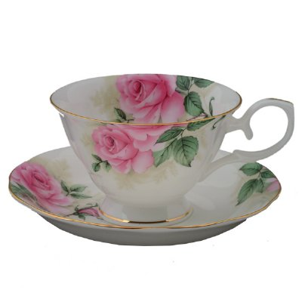
3rd December Gourmet Goodies Stall at Beaudesert Markets
July 2012 Zonta International Convention – Torino, Italy

COFFEE MORNING
Thursday 1st December Beaudesert Cafe – 10am

LAUNCH OF DOMESTIC VIOLENCE AWARENESS CALENDAR
Friday 25th November 10am at The Centre
We will be purchasing some food, but if anyone would like to offer to bake
something, that would be appreciated.
GOURMET GOODIES STALL
A roster will be circulating so please write down what you are able to make or bake for the stall & if you can work on the day.
We have approval to sell raffle tickets outside Shay’s Pharmacy
On 17th ,18th , 24th & 25th November, as well as the 1st & 2nd December - in the mornings. Is anyone able to help with this?

MISSION STATEMENT
Zonta International is a worldwide organisation of executives in business and the professions, working together to advance the status of women.

