ZONTA Club of Roma
Zonta International
is a worldwide service organization of executives in business and the professions working together to advance the status of women.
Club Number 1432
Chartered 26 August 1993
P. O. Box 1003, Roma, Q 4455

Newsletter – November 2007

District Governor: Patricia Lawson Area Director: Ans Van Erp

President’s Report
Heather Hall
Membership & Fellowship
Robyn Mackay

The past month has been incredibly busy for the Roma club but at the same time a fantastic time for our fund raising. The Spirit of the Bush concert was a major success for the club and also highlighted the enormous capacity of the service clubs of Roma to work together. As yet the final result of the fund raising for the clubs is not available but it will be a major injection into club funds. For those who did the work thank you, you did Zonta proud. A particular thanks to our Honzons who, once again, did such a lot. I think we all learnt something from this process and this can be used in future activities.
Last weekend saw a first for our club when we catered for the afternoon tea at the Roma Cup, again a very successful event raising appox $800 for Zonta. Again we learnt a lot and take this experience forward into future events. I personally don’t think I want to dip and roll another lamington for a long time and I believe the Hutchinson family are still wading through the pumpkin scones Janice made.
This event was made possible by Robyn Mackay and her committee, again thank you.
A special thank you to Paul H, Janice’s Honzon who was both chief dishwasher and manned the entry table.
In the last report I mentioned the Caloundra club’s project – Shoe Boxes of Love. This I’m pleased to report has worked very well with the boxes being delivered here to Roma by Eunice from Caloundra. From there I have taken some boxes to Blackall and Barcaldine with the remainder going to Charleville tomorrow for delivery to Aussie Helpers so they can take them further on to women in the western areas who are still battling drought and rural recession. This project is a perfect example of how simple collaboration from a few people can have a wonderful effect on many others, truly Australian Zonta spirit.
As the year draws to a close we now have to turn our thought s to the nominating committee which will assist in determining the future structure of the club. In the manual under Section 4 is a very good explanation of this process which we will discuss at the dinner meeting on Tuesday.
Dec 1st is our Christmas Party at Explorers Inn which will be an ideal opportunity to celebrate our year and the festive season.
Dec 6th is the Roma street party so we will start discussing this at the dinner meeting also.
Our happy Sagittarians,
Jill Frith on the 2nd, Denise Martin on the 6th & Judy Harland on the 15th
and Capricorns, Janice Hutchinson 27th & Lesley Dillon on the 31st .

Another month has gone by and we have been very busy Zontians. We had a terrific fellowship afternoon at Pam Fisher’s home, talking, laughing and enjoying the art of Lamington preparation for the Roma Cup afternoon tea on Saturday 17th November.
Some of us had no clue as to the procedure but we learned a lot and may I say they taste yummy.
We haven’t again had time for an OMC meeting, but I have seen and spoken many times to most our group personally and via email, so we never lose touch.
Our fellowship extends to our Xmas Party at Explorers Inn and I urge you to indicate to Gill Swires if you and your Honzon are going ASAP so that final plans can be made.
If you would like to participate in the ‘Secret Santa’ for yourself and your Honzon please buy a gift to the value of $10 - $15 and bring it with you on the night. Honzons will of course be allocated presents from the Honzon stocking. There is of course no obligation if you do not want to participate but it is a lot of fun.
Can I also remind all members who haven’t as yet done so to bring a bottle of wine to the meeting on Tuesday night for our Xmas wine raffle (tickets are free on the night of the party). If you don’t remember you will be required to purchase one from the Maranoa Club.
If anyone has a name of someone who would be interested in an Orientation Function in the New Year please fill out the form I sent via email or let me know and I will follow it up with you.
A huge thank you comes from me and goes to the Zontians who helped out by supplying food and came along on the day to work for the Roma Cup Afternoon Tea.
It was fantastic effort by 12 members and an Honzon (who did a magic job of the washing up). Our Treasurer will tell us how we did, but I believe it was well worth the sore feet.

P.R. & Communications
Denise Martin

The main topic of the P R Committee meeting was the signage for the Roma Cup Afternoon Tea. It was decided to make about half a dozen signs and distribute them around Bassett Park as well as our Zonta Signboard (which is available to anyone for use and can be found at H. Hobb’s office).
This done we then discussed future directions. Kell checked in by phone to assure us that Liz Frith would be our guest speaker at the November meeting.
The topic of the newsletter must come up again. I will not be here for Dec, Jan, June, July and possibly August so that suggests someone else must take the reins. Is there someone, not already in the PR committee who feels sufficiently “computer literate” to take on the job? (Our committee members already fill the positions of Minutes Secretary and Correspondence Secretary) Really it is only Word and being able to type….
Clubs are always changing and I’d encourage anyone to take up the challenge of a new position. Of course we are also looking for a new Treasurer.
Finance & Fundraising
Mary Teakle

This month our committee met at Café 54 and discussed a number of topics.
- SPIRIT OF THE BUSH: We still have a few outstanding bills to pay before we can wrap up and distribute funds to each service club. A very big thank you to each and everyone including the Honzons for such a successful team effort with all the clubs working so well together. A special thank you to Honzon, Noel Dillon, for all his hard work in preparation before the event and also in the organisation of the day.
- ROMA CUP AFTERNOON TEA: Thank you to Robyn and all who helped in organising and working on the day. It was a successful day and we made over $1000 less a few expenses. All up, it was a great effort!
- STREET PARTY: 6th December will be our next project. We are in the process of organising the drinks etc. As they say “many hands make light work” so if you are able to help on the afternoon/evening it would be greatly appreciated.
- ART UNION TICKETS:
Please return Art Union tickets and money at this month’s dinner meeting.
We need to have them ready for the draw on 3rd of December - on air at 4ZR. If you are unable to make the meeting, please drop them to Mary or Jill (Sabine) at NAB bank. The final ticket selling will be
Sat, 24th Nov… Jo and Heather M at the Plaza
Sun, 25th Nov… Heather H and Robyn Bakearoma
DATES TO PUT IN THE DIARY

- 27th November - Dinner Meeting - at the Maranoa Club at 6:00pm.
- 1st December - Christmas Party - at Explorer’s Inn
- 6th December - Christmas Street Party
- 18th December -Final Board Meeting for 2007
NO DINNER MEETING IN DECEMBER
- 15th January - First Board Meeting for 2008
- 22nd January - First Dinner Meeting for 2008
- 26th January - Australia Day Drinks Stall

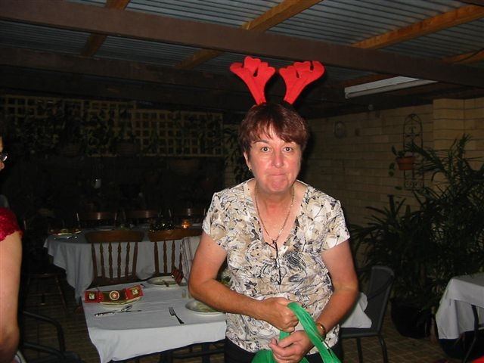
The editor takes no responsibility for the contributions of members to this newsletter!
If you don't bring a bottle on Tuesday (if you haven't already done so) we will have the chief reindeer after you, there are still a number of outstanding bottles!
For the newer members of the club, this started as a fundraiser for our members account, we donated a bottle then sold, yes sold the tickets to our long suffering Honzons and ourselves to get a bit of money in the account. Luckily these days we are a little more financial so do it for fun. Depending on the number of bottles I receive I will divide them into lucky draws, no money needed! and it is all good fun.
Thankyou for your support, see you on Tuesday
Jenny L.

1st December at 1 Explorers Inn
R.S.V.P. to Gill Swires
november roster
duty | zontian | date
Blessing | H. Geary | 27th Nov
Objects | J. Frith | 27th Nov
Raffle | Vicki H/ Lesley D | 27th Nov
Meals on Wheels | Barbara Ruthof | 28th Nov
NOVEMBER MEETING
Maranoa Club - Tuesday 27th November 2007
Please contact if you are unable to attend
Gill Swires 4622 7068……..…0428 327 068
In the absence of an apology, an invoice for $15 will be sent to non-attending members to cover the cost of their meal.

